PROFORMA FOR RECOMMENDING NSS UNIT & PROGRAMME OFFICER KUVEMPU UNIVERSITY NSS AWARDS
Dr.MOHANA H.S
1. | Name of the state | Karnataka
2 | Name of the University | Kuvempu university
3 | Name of the college | SAHYADRI ARTS COLLEGE
4 | NAME OF PRINCIPAL OF THE THE COLLEGE | DR.DHANAJAYA K B  SAHYADRI ARTS COLLEGE SHIVAMOGGA 577203
5 | Name ,sex and contact particulars of the programme officer | Dr. MOHANA H S  Asst.Professor, Dept.of Kannada  Sahyadri Arts College  Shimogga
6 | Name of the NSS unit which is being recommended for Award and data from which the NSS unit is in existence | Sahyadri Arts College Unit -1 2016-17.
7 | Period of service as programme officer if the nss unit: | 2016-17 to 2018-19
8 | Whether the programme officer is trained at ETI | Yes 03-11-2016 to 09-11-2016 ETI Mysore
9 | Whether strength of NSS unit being recommended for Award is as per guidelines during last 3 years?  (please indicate allocation of target and actual enrolment during last 3 years i.e during 2016-17,17-18,18-19) | 2016-17 200 220  2017-18 200 240  2018-19 200 220
10 | Adopting of village /slums and completion of special camping against targets  (please indicate target special camping and actual achievement during last 3 years i.e during 2016-17,17-18,18-19) | Special village camp -3.  University Level Inter Collegate Camp-3.  Leadarship Camp-1.  Special Training ,Seminar,Workshop- 3
11 | Whether the programme officer has been convicated by a court of law ar any case investigation is pending against him/her? (certificate from the competent authority of the college to be attached) | no
12 | Performance/significant achievements of the NSS unit during 2016-17,17-18,18-19  (extra sheets for details of the achievements)  - Plantation (no of programme arganised and saplings planted  - blood donation no of camp arganized and blood units donated  - health/eye/immunizations camp( no of camps arganiged)  - awareness programmes (aids/ environmental/other.no of progrmme arganised | Programme | 2016-17 | 17-18 |  | 18-19
 |  | Plantation | 400 | 350 |  | 1100
 |  | Blood Checkup | 01 | 01 |  | 01
 |  | Blood Donation | 00 | 01 |  | 00
 |  | Aids Awareness | 01 | 01 |  | 01
 |  | Eye Pledge | 00 | 01 |  | 00
 |  | Dental Check Up | 01 | 01 |  | 00
 |  | General Health Checkup | 01 | 01 |  | 01
 |  | Health Awareness Programme in Ladies Hostel | 03 | 02 |  | 03
 |  | Cleaning Awereness | 04 | 03 |  | 04
 |  | Mounoment Preservation  Awareness | 01 | 00 |  | 01
 |  | Electionoting Awareness | 00 | 00 |  | 03
 |  | Drug Awareness | 00 | 02 |  | 01
 | - Creation duration asseests ( estimated value of assests) | Road - Km  School Field Levelling  Formation of Drainage
f) awards received details
are given separatally
13 | Whether the day duty filled –up cheak list has been attached | yes
14 | Other remarks, If any

The NSS Unit to be considered for the Award shall be a single NSS Unit. Thus, in case a Programme Officer is in-charge of more than one NSS Units for any reason, one of such Units should be identified and all the data in this Proforma should be furnished for that particular unit only.

Signature of the P O | Signature of the Principal | Signature of the Programme coordinator
Signature of the Vice Chancellor/Chairman | Signature of the SNO | Signature of the Competent Authority in the State/UT

CHECKLIST for
KUVEMPU UNIVERSITY NSS Awards for NSS Unit/Programme Officers

Name of the NSS Unit: SAHYADRI ARTS COLLEGE

Programme Officer: Dr. MOHAN H. S.

- Eligibility Criteria:

SlNo
1. | Whether the NSS Unit has been in existence continuously for 5 years, i.e. during 2012-13 and onwards? | Yes
2. | Whether the strength of the NSS Unit is as per guidelines during 2015-16 and 2016-17 and 2017-18 | Yes
3. | Whether the NSS Unit has adopted village/slum as per guidelines and has completed the Special Comping targets during last 3 years, i.e. during 2014-15, 2015-16, 2016-17, and 2017-18 ? | Yes
4. | Whether the Programme Officer has completed minimum two years as Programme Officer of the NSS unit being recommended for award (as on 31.03.2018)? | Yes
5. | Whether the Programme Officer has been trained at ETI? | Yes
6. | Whether the Programme Officer has been convicted by a court of law or any case/investigation is pending against him/her? | Yes

- Performance/Achievements:
SL. No. | Parameter | Factual Position
 |  | 2014-15 | 2015-16 | 2016-17 | 2017-18
1. | Plantation  - No. of plantation programmes organised | 01 | 02 | 02 | 02
 | - No. of Saplings planted in these programmes | 35 | 50 | 80 | 150
2. | Plantation  - No. of Blood Donation Camps organised | 01 | 02 | 01 | 01
 | - Blood Donated in the Campus(No. of Units) | 42 | 40 | 120 | 121
3. | Health/Eye/Immunisation Camps  - No. of Camps organised | 01 | 01 | 01 | 01
4. | Awareness/Programmes/ Rallies/Campaigns/ Organised:
 | - Aids Awareness(No. of Programme | 01 | 01 | 01 | 01
 | - Environment Awareness(No. of Programmes) | 01 | 01 | 01 | 01
 | - Other Awareness Programme (Please indicate the name of the Awareness Programme and number of programs organised) | 01 | 02 | 01 | 01
 | - Health Awareness and Cleaning Awareness | 02 | 02 | 02 | 02
5. | Creation of Durable Assets  - Estimated Value of the Assets created (Rs.) | 1.5 lakh | 2.5 lakh | 2. lakh | 2.8 lakh
6. | National Level Camps/Awards  - Awards at State level and above(Please indicate the names of the Awards) | - | - | - | -
 | - Awards below State Level (Please indicate the names of the Awards
7. | Other Outstanding Achievements:  Please indicate details of each such achievement) |  | Participatd in National Level Conference on NSS organized by Mysore University | Guided Students to present a Paper on NSS in State Conference
Note: The details mentioned above should tally with those given in the main Proposal. In case of Major diviation, the proposal will be liable to rejection

Principal Signature of Competent Authority in State/UT
(With office seal)

RESUME

1 | Name | Dr.MOHANA .H S
2 | Father’s name | Shivappa I
3 | Date of birth | 03-06-1971
4 | Officel address | Asst.Professor.Dept of Kannada.  Sahyadri Arts College Shivamogga
5 | Permanent address | Chandragutti,Sorab 577429  9480544099  mohancgutti@gmail.com
6 | educational qualification
 |  | B A | 1994-97
 |  | M A | 1997-99
 |  | Ph D | 2006
7 | Teaching experience | 10 years
8 | Orientation | 03-08-2013 to 01-09-2013 Orientation Course at Mysore
9 | refresher course | Refresher Course Mysore-  1)22-07-2014 to 11-08-2014  2)21-12-2017to10-01-2018
10 | Seminars /workshops/ conferences attended |  | Organized | participated
 |  | State | 03 | 15
 |  | National | 00 | 10
 |  | International | 00 | 02
11 | As resource person | - Alva’s Nudisiri –Karnatakad Vartamanada Tallanagalu 2014  - Traibal Knowledge :Kannada University Hampi ,November 28,29.30 Dandeli  - Pampana Kavyagalu:Kadambotsva Banavasi Feb 2,3 /2018  - Tribal Studies: Theoretical Analysis- Kannada University Hampi Feb 8 to 11 2016 Sirasi  - Karanataka Folk Epics – Kendra Sahitya Academi ; March 27,28 2017 Sagar  - Visiting Fellow; Departament Of Tribal Studies Kannada University Hampi
12 | paper /presentation /published | 02 International, 15 National, 15 State Papers And Journal
13 | Book published : | 2015 To2019  - Devaraj Arasu –Sirigananda Pustaka Mane 2015 Isbn978-93-81876-42-3  - Mukri Samudaya –Dr.B R Ambedkar Study And Reasch Center ,Social Welfair Dept Bangalore -2016  - Itaa Hejje Ditta Guri –Sirigannad Pustakamane-2019  - Belaku Beleda Kathana- Dr.B R Ambedkar And Boudha Research Center Kuvempu University- On Printing  - Vicara Sahitya-(E) Karnataka Sahitya Acedamy Bangaloru 2019-Submitted  - Hase Chittara-Traibel Art Book- Tumakuru 2018  - Sahitya Sangati(E) Text Book For 1st B A Kannada Opt 2018
14 | Acadamic activities other than teaching | - BOS Member Govt Arts College Chitradurga  - Reasearch Guidance- Total Enrolled 09.  - Awarded-01.Submitted-01  - Projct :  - A Study Of Minor SC Community: Mukrigalu- Dept Of Social Welfare Banagalore 2016  - DR.Ambedkar’s Influence on Shivamogga 2016-17  Kuvempu University  - Coordinator – UG Regular And Distance Evaluation Of Kuvempu University 2014 To 2019
15 | Honours And Awards If Any:- | - Best NSS Volunteer Sate Award 1998  - University Best NSS Volunteer Award 1997  - DR.ApJ Abdul Kalam Life Time Achievement National Award For Teaching and Reaserach-2019 International Institute for Social and Economic Reforms Bangalore
16 | Community Outreach Programme | 1.Tribal Art Workshops In Village  2.Health Awerness Programme in Wemen;s Hostels  3.Drug Awarness Programme in Village
17 | Co-Curricular Activitice | Writing Articles in Regional Papers, and Speeches in All India Radio.,
18 | Hobbies | Reading, Plyaing Street Drama, Singing

KUVEMPU UNIVERSITY
SAHYADRI ARTS COLLEGE, SHIVAMOGGA
NSS

CAMP -01 | 22th Inter College University Level Camp-2017 Sahyadri Arts College. Number Of Volunteers Participated - 210  11/07/2016 to 17/07/2016
Goals: | - Cleaning college premisis 10000=00  - Plastic free zone 5 acer 10000=00  - Plya ground leveling 2acer 20000=00  - Road construction 500 meeter 10000=00  - Main intensn is skill development  - Leadership quality developmemt
Achievements: | - Botanical Garden construction  200 meter road and 400 meter drainage construction 10000=00  - Path way for the Green Library 1 km 10000-00  - Repairing Pampavana 10000=00  - Planting 1,000 Saplings 10000=00  - Cleaning 10acer 25000=00

Guest
1.pro.jogan Shankar hon, vice ch
2.sri.h t krishnamurty. Assit comm.. shimogga .dreem india
3.dr.j somashekar pro. Youth and ledership
4.v. s .l kumar sec redcros buetiful life
4.arun pujarregenal centar nss bangalor
6 dr.ganatha shetty ekkaru stste lisening officer
- Dr.rajeshvari n life skill

Traing program
1.drama training 2. Songs traing 3.stage mentenens.4speech

KUVEMPU UNIVERSITY
SAHYADRI ARTS COLLEGE, SHIVAMOGGA
NSS

CAMP -02 | 23th Inter College University level camp-2017 University  Campus, Gnana Sahyadri, Shankaghtta. Number of volunteers participated - 200  04-07-2017 to 10-07-2017
Goals: | - Under the Guidance of Botany department construction of Botanical Garden  - Under the guidance of estate department construction of walking way to green library.  - Cleaning of walking passage of pampavana  - Main intensn is skill development  - Leadership quality developmemt
Achievements: | - Botanical Garden construction  200 meter road and 400 meter drainage construction 10000=00  - Path way for the Green Library 1 km 10000-00  - Repairing Pampavana 10000=00  - Planting 1,000 Saplings 10000=00  - Cleaning 10acer 25000=00

Gest 1. Chennabasappa. Adi.dc computatev exam
2. dr.tippeswami . students andgovt aprtunaty
3.dr.prashant nayaka – new life constructin
4 v s l kumar urth quick
5.dr.jogan Shankar vc
6bhojyanaik register
- Dr.ganat shetty ekkaru
- Kartikeyan
- Wr m venkateshavrlu rgester tumakuru university

Traing program

1.drama training 2. Songs traing 3.stage mentenens.4speech

KUVEMPU UNIVERSITY
SAHYADRI ARTS COLLEGE, SHIVAMOGGA
NSS

CAMP 03: | 24th Inter College University level camp-2018 University Campus  Number of volunteers participated 240  10/06/2018 to16/06/2018
Goals: | - Plastic free campus announcement  - Our campus Green lampus  - Plastic free Campus  - Dram and Song Training  - Teaching (Yoga Training march fast training  - Personality Development Training  - Disaster awerness programme
Achievements: | - Announcing Plastic free Campus cleaning totel campus 25000=00  - Under my Campus Green Campus we planned 1000 trees 10000=oo  - Cleaning Campus 10acer 25000=00  - Basic NSS programme teachin

- .dr.jogan Shankar vc
- bhojyanaik register
- Dr.ganat shetty ekkaru
- Dr. m venkateshvaralu. Prof az
- Dr.yogendra environmental
- Vsl kumara

Traing program
1.drama training 2. Songs traing

KUVEMPU UNIVERSITY
SAHYADRI ARTS COLLEGE, SHIVAMOGGA

CAMP 01: | Special annual Camp – Dodda Mattali – 2017  Doddamathali, Mandaghata Grama Panchaiti 24 k.m. away from Shivamogga  Number of Vounteers participate-105  Sahyadri Arts College – 85, Tumkur University-10  Lecturers – 05, Senior Vounters-05  Under the Government and private or diviation  - Grama panchayath, Mandaghatta  - Metro Hospital, Shivamogga  - Agricultural University Shivamogga  - Sharavathi Detal College, Shivamogga  - Revenue Department,  - Health centre Mandaghatta.  - Disable welfare department Shivamogga
Goals: | - Rural owners  - Sharandhan  - Health awareness  - Self employment training  - Activities for School Children  - Introduction of forest Act.
Achievements: | 1. | Road ride cannel construction approrially 2k.m. 20000=00
 | 2. | Foundation for Hulliammma Devallaya Samudaya Bhavan. 10000=00
 | 3. | Cleaning of the Hulliamma temple. 2acer 5000=00
 | 4. | With he help of donors distribution 100 cocunut saplings to the people  100 rs per tree 10000=oo
 | 5. | Blood grouping card was given with the help of the Health Department.
 | 6. | With the help of the Revenue department 25 Adhar card, 10 Votor cads were issued.
 | 7. | With the help of the Disable Welfare Department issued wheel chair.
 | 8. | Dental checkup was done with the help of Sharavathi dental college.  50 2500=oo
 | 9. | Health checkup was done with the help of the Meggan hospital Shivamogga 250 12500=00
 | 10. | Drama and song training was given to the volunteers.
 | 11. | Blood Grouping was done.
 | 12. | Introducing the Government Politics by Deputy Commissioner and divisional officer, Destrict welfare Department and Forest Department.
 | 13. | Cleaning of the main lake of the village the happy moments of the visit of The Vice-chancellor of the Agrucultural University for the inugral programme of the camp.

Guest
- Dr. gd narayanppa
- Dr.prakruti manacle
- Pro.manjunath k naik. Hon vice chanseler agri university shivamogga
- Sri chennabasappa a adc shivamogga
- Sri krishnamurty k k ac shivamogga
- Shivakumar dd social wlfer
- Smt sharadapuranaik mla shimogga
Trining
1.k c basavaraju oters day
2.drama training guruprasad,ganesh kenchanal
3.songs - dr b s nagesh
2mushruom traing ahus

KUVEMPU UNIVERSITY
SAHYADRI ARTS COLLEGE, SHIVAMOGGA

CAMP- 02 | Special Annual Camp – Adina Kottege – 2018  Adira Kottege, Mandghatta Gramapanchayat  Number of volunteers Participated-100  Colleberaarior  - Horticulture and Agricultural university, Shivamogga  - Revenue Department Shivamogga  - Rude set self employment training Invitate Holaluru  - Forest Department, Shivamogga  - Metro Hospital Shivamogga  - Ramakrishna Charitable trust, Shivamogga  - Mahatma Gandhi rural development trust, Shivamogga
Goals: | - Free medical check up camp  - Repairs to rural road.clearing weeds on both sides of road connecting doddamattali to adinkottige  - Repairs and cleaning of school campus,tempal sorunding  - Awernes of wemens to health  - self emplaiment plans  - Folk arts and folk culture
Achievements: | 1. | Approtunity 1000 meters construction of road.
 | 2. | Premissing the property f Samudhaya Bhavan
 | 3. | Cleaning the cannal nearly 2k.m.
 | 4. | First NSS Folk musiam in Karnataka abou 200 metirials in this museum
 | 5. | Small huts for school children purpes of library
 | 06 | Awernes of forest and wildlife
Guest |  | - Hon kagodu timmappa minister of revenue  - 2.pro jogan shankara vc  - Smt sharada puryanaik mla shivamogga  - Sri chandrahasa editar prajavani  - Sri mukundachand dcf .shimogga  - Jagadish sampalli Indian express  - Nityananda shivagange digvijaya t v  - Dharmaraj n p member backward classa commission
Traing program |  | 1.drama training 2. Songs traing 3.self emliament training.4 mashrum training

KUVEMPU UNIVERSITY
SAHYADRI ARTS COLLEGE, SHIVAMOGGA

CAMP -03: | Special annual camp- 2019  Rechikoppa. Mandaghatta gram panchayat  Shivamogga talluku  Totel volunteers 103  Officers 04  Totl members 107  coardination  1.deputy commissioner office shivamogga  2.Forest dept shivamogga  3.vatsalya hospitals shivamogga  4.Neharu yuvakendre shivamogga  5.Dessable wellfair dept shivamogga  6.vartah pracahra dept  7.Shri Ramkrishna charitable trust shivamogga  8.Sree Mahatmaghandhi rural development trust  9.sahyadri drama team
Goals: | 1.coardination with rural people  2.shramadhan  3.health awerness  4. self employment training  5.activitis for school children.  6.awerness of forest act  7.bairds watching  8.otingawerness programme
Achievements: | 1. | approximetaly 2 km road construction | 40000=00
 | 2. | Formation Of school ground 1000/sq.ft 25 sq | 25000=00
 | 3. | 2 km road side cleaning | 5000=00
 | 4. | Health check up was don with the help of vatsally hospital 150 people 200*50 | 10000=00
 | 5. | Repair to drainege 1 km | 5000=00
 | 6. | Leveling of school ground 1acre | 10000=00
Geust |  | 1.dr.nagesh b s  2.dr.shripati halgunda  3 tukaram gouda  Dr.giridhar k v
Training
1. Traing program
1.drama training
2. Songs traing
3.self emliament training.
4 mashrum training

KUVEMPU UNIVERSITY
SAHYADRI ARTS COLLEGE, SHIVAMOGGA

Participation of the NSS voulunteers at different workshop and comps during year 2018-19
Goals: | Camp/workshop name | venu | date | no of volunteer
 | - university level camp | shankarghatta
 | - State youth fest | dharavada | 12,to16/10 2018 | 02
 | - NIC | belgavi | 23 to 29/11/2018 | 02
 | - NIC | udupi | 29 to 04/02/2019 | 02
 | - NIC | mandi himachalapradesh | 12 to 18/02/2108 | 06
 | - Svachatha shibira | shivamogga | 24 to 02/o3/2019 | 03
 | - NIC | belagav | 27 to 05/o3/2019 | 03
 | - District level camp | shivamogga | 29to05/06/208 | 15
 | - RDpared selection camp | belagavi | 03 to 07 /10/2018 | 01
 | - RDpared south Zone selection camp | Bangalore |  | 01
 | - RD pared | Bangalore | 14 to 27/01/2019 | 01
 | - National trucking camp | manali | 22 to 01-102018 | 01
9th rank in BA digri exam girish nayayk
Ku. Swathi gh university best volinter award
Ku mamatha state rd pared

KUVEMPU UNIVERSITY
SAHYADRI ARTS COLLEGE, SHIVAMOGGA
Participation of the NSS voulunteers at different workshop and comps during year 2017-18
Goals: | Camp/workshop name | venu | date | no of volunteer
 | - NIC | shankaraghatt | 02 to 08 march 2018 | 04
 | - statefest | udupi | 18-08-2017 to 22-08-2017 | 02
 | - NIC | vijayapur | 25 to31/03/18 | 04
 | - NIC | bangalor | 15 to 21/03/18 | 02
 | - NIC | dharavada |  | 01
 | - NIC | mysore | 20 to26/03/18 | 02
 | - State fest | mysore | 28 to01/04/18 | 04
 | - university ic camp | shankarghatt | 04/ 10-07-2017 | 30
 | - disrtict level camp | shivamogga | 12 to18/12/2017 | 12
 | - Palaiha n ANIKETHANA gold medalest |  |  | 02/12/17
- Kavyashri BA 6 rank
Ku nayyasri university best volunteer awrd

KUVEMPU UNIVERSITY
SAHYADRI ARTS COLLEGE, SHIVAMOGGA

Participation of the NSS voulunteers at different workshop and comps during year 2016-17
Goals: | Camp/workshop name | venu | date | no of volunteer
 | - Nic | shivamogga | 24to30/01/217 | 02
 | - university ic camp | shivamogga | 11to17/07/2016 | 40
 | - vivekananda jayanti | Bangalore | 18/01/2016 | 60
 | - Nym camp | arsikere | 26 to05/03/2017 | 13
 | - district camp | machenahalli | 03 to09/04/17 | 16
 | - NIC | udupi | 22 to28/02/2017 | 04
 | - NIC | mysor |  | 02
 | - RD selection camp | Bangalore | 22 to25/09/16 | 03
 | - southzone selection camp |  |  | 01
 | - RD pared | dehali | 01 to31 january 2017 | 01
 | - NIC | Dharavad |  | 01
Palayya state best NSS volunteer award 2016-17
Sandipa m national rd pared

2016-17 £ÉÃ ¸Á°£À gÁ¶ÖçÃAiÀÄ ¸ÉÃªÁ AiÉÆÃd£ÉAiÀÄ ªÁ¶ðPÀ ªÀgÀ¢
¸ÀºÁå¢æ PÁ¯ÉÃf£À°è gÁ¶ÖçÃAiÀÄ ¸ÉÃªÁ AiÉÆÃd£ÉAiÀÄ vÀ¯Á 100 ¸ÀéAiÀÄA ¸ÉÃªÀPÀgÀÄUÀ¼À JgÀqÀÄ WÀlPÀUÀ½zÀÄÝ, WÀlPÀ-1gÀ C¢üPÁjAiÀiÁV qÁ. ºÉZï.J¸ï. ªÉÆÃºÀ£À ªÀÄvÀÄÛ WÀlPÀ-2gÀ C¢üPÁjAiÀiÁV qÁ. ªÀÄAdÄ£Áxï ºÉZï.¦. PÁAiÀÄð¤ªÀð»¸ÀÄwÛzÁÝgÉ. DUÀµïÖ wAUÀ¼À°è ¸À®ºÁ ¸À«Äw gÀa¹ ªÀÄÄA¢£À PÁAiÀÄðPÀæªÀÄUÀ¼À §UÉÎ ¤zsÁðgÀ vÉUÉzÀÄPÉÆ¼Àî®¬ÄvÀÄ.
gÁ.¸ÉÃ.AiÉÆÃ.AiÀÄ GzÁÏl£Á ¸ÀªÀiÁgÀA¨sÀªÀÅ ¢£ÁAPÀ: 23/08/2016gÀAzÀÄ £ÉgÀªÉÃjvÀÄ. GzÁÏl£É ªÀiÁrzÀªÀgÀÄ qÁ. ¸ÀtÚgÁªÀÄ, «±ÁæAvÀ ¥ÁæzsÁå¥ÀPÀgÀÄ, EªÀgÀÄ zÉÃªÀgÁdÄ CgÀ¸ÀÄ CªÀgÀ£ÀÄß PÀÄjvÀAvÉ «±ÉÃµÀ G¥À£Áå¸À ¤ÃrzÀgÀÄ.
¢£ÁAPÀ: 11/07/2016 jAzÀ 17/07/2016gÀªÀgÉUÉ CAvÀgï PÁ¯ÉÃdÄ PÀÄªÉA¥ÀÄ «±Àé«zÁå¤®AiÀÄ PÁ¯ÉÃdÄ ªÀÄlÖzÀ ²©gÀªÀ£ÀÄß £ÀqÉ¸À¯Á¬ÄvÀÄ. EzÀgÀ°è ««zsÀ PÁ¯ÉÃdÄUÀ¼À 200 ¨sÁUÀªÀ»¹zÀÝgÀÄ EzÀgÀ°è £ÀªÀÄä PÁ¯ÉÃf£À 40 «zÁåyðUÀ¼ÀÄ ¨sÁUÀªÀ»¹zÀÝgÀÄ.
¢£ÁAPÀ: 22/08/2016gÀ wgÀAUÁ ªÀiÁZïð £ÀªÀÄä WÀlPÀzÀ 140 ¸ÀéAiÀÄA ¸ÉÃªÀPÀgÀÄ ¨sÁUÀªÀ»¹zÀÝgÀÄ.
¢£ÁAPÀ: 24/08/2016gÀAzÀÄ gÁ¶ÖçÃAiÀÄ PÁ£ÀÆ£ÀÄ ¸ÉÃªÉUÀ¼À ¥Áæ¢üPÁgÀzÀ AiÉÆÃd£É CrAiÀÄ°è ªÀiÁzÀPÀ ªÀ¸ÀÄÛUÀ¼À ªÀå¸À£À ºÁUÀÆ ¤ªÁgÀuÁ PÁAiÀÄðPÀæªÀÄªÀ£ÀÄß £ÀqÉ¸À¯Á¬ÄvÀÄ.
¢£ÁAPÀ: 26/08/2016gÀAzÀÄ PÀªÀÄ® £ÉºÀgÀÄ ªÀÄ»¼Á PÁ¯ÉÃf£À°è £ÀqÉzÀ zÉÃªÀgÁdÄ CgÀ¸ÀÄgÀªÀgÀ ºÀÄlÄÖ ºÀ§âzÀ PÁAiÀÄðPÀæªÀÄzÀ°è 07 ¸ÀéAiÀÄA ¸ÉÃªÀPÀgÀÄ ¨sÁUÀªÀ»¹zÀÝgÀÄ.
¢£ÁAPÀ: 29/08/2016gÀAzÀÄ PÀÄªÉA¥ÀÄ «±Àé«zÁå¤®AiÀÄ gÁ.¸ÉÃ.AiÉÆÃ. ªÀw¬ÄAzÀ £ÀqÉzÀ gÁ¶ÖçÃAiÀÄ ¥ÀPÁégÀ PÁAiÀÄðPÀæªÀÄzÀ°è 42 «zÁåyðUÀ¼ÀÄ ¨sÁUÀªÀ»¹zÀÝgÀÄ.
¢£ÁAPÀ: 30/08/2016gÀAzÀÄ £ÀªÀÄä PÁ¯ÉÃf£À gÁ.¸ÉÃ.AiÉÆÃ. 25 «zÁåyðUÀ¼ÀÄ HgÀÄUÀqÀÆgÀÄ UÁæªÀÄzÀ ¨ÉlÖzÀ°è ¸ÀéZÀÒvÁ DAzÉÆÃ®£À, VqÀUÀtwAiÀÄ°è ¨sÁUÀªÀ»¹zÀÝgÀÄ.
¢£ÁAPÀ: 10/09/2016gÀAzÀÄ ¦.E.J¸ï. PÁ¯ÉÃf£À°è £ÀqÉzÀ NjAiÀÄAmÉÃµÀ£ï PÁAiÀÄðPÀæªÀÄzÀ°è 15 ¸ÀéAiÀÄA ¸ÉÃªÀPÀgÀÄ ¨sÁUÀªÀ»¹zÀÝgÀÄ.
¢£ÁAPÀ: 02/10/2016gÀAzÀÄ UÁA¢ü dAiÀÄAw PÁAiÀÄðPÀæªÀÄªÀ£ÀÄß K¥Àðr¸À¯ÁVvÀÄÛ. 30 ¸ÀéAiÀÄA¸ÉÃªÀPÀgÀÄ ¥ÁæxÀð£ÉAiÀÄ°è ¥Á¯ÉÆÎArzÀÝgÀÄ.
¢£ÁAPÀ: 03/01/2017gÀAzÀÄ £ÀqÉzÀ r.«.J¸ï. PÀ¯Á PÁ¯ÉÃf£À°è £ÀqÉzÀ rfl¯ï EArAiÀiÁ PÁAiÀÄðPÀæªÀÄzÀ°è £ÀªÀÄä PÁ¯ÉÃf£À 10 «zÁåyðUÀ¼ÀÄ ¨sÁUÀªÀ»¹zÀÝgÀÄ.
¢£ÁAPÀ: 18/01/2017gÀ°è ¨ÉAUÀ¼ÀÆj£À CgÀªÀÄ£É ªÉÄÊzÁ£ÀzÀ°è £ÀqÉzÀ ¸Áé«Ä «ªÉÃPÁ£ÀAzÀ dAiÀÄAwAiÀÄ°è £ÀªÀÄä PÁ¯ÉÃf£À 50 d£À «zÁåyðUÀ¼ÀÄ ¨sÁUÀªÀ»¹zÀÝgÀÄ. eÉÆvÉUÉ vÀÄªÀÄPÀÆgÀÄ «.«. J£ï.J¸ï.J¸ï. C¢üPÁjUÀ¼ÉÆA¢UÉ ZÀZÉð £ÀqÉ¸À¯ÁVvÀÄÛ.
¢£ÁAPÀ: 25/01/2017jAzÀ MAzÀÄ 01/02/2017gÀªÀgÉUÉ zÉÆqÀØªÀÄvÀÛ°, ²ªÀªÉÆUÀÎ (vÁ) E°è «±ÉÃµÀ ªÁ¶ðPÀ ²©gÀ K¥Àðr¸À¯ÁVvÀÄÛ. EzÀgÀ°è vÀÄªÀÄPÀÆgÀÄ «.«.AiÀÄ 10 «zÁåyðUÀ¼ÀÄ ¸ÉÃjzÀAvÉ 100 «zÁåyðUÀ¼ÀÄ ²©gÀzÀ°èzÀÝgÀÄ. F ²©gÀzÀ°è ¸ÀPÁðgÀzÀ ºÀ®ªÀÅ PÁAiÀÄðPÀæªÀÄUÀ¼À£ÀÄß AiÀÄ±À¹éAiÀiÁV eÁjUÉÆ½¸À¯ÁVvÀÄÛ.
¢£ÁAPÀ: 03/03/2017gÀAzÀÄ UÁæºÀPÀgÀ ªÉÃ¢PÉAiÀÄ ¸ÀºÀAiÉÆÃUÀzÉÆA¢UÉ UÁæºÀPÀ »vÀgÀPÀëuÁ PÁAiÉÄÝ ªÀÄvÀÄÛ rfl¯ï EArAiÀiÁ PÀÄjvÀÄ G¥À£Áå¸À K¥Àðr¸À¯ÁVvÀÄÛ..
¢£ÁAPÀ: 11/03/2017gÀAzÀÄ gÀPÀÛ¤¢ü f¯Áè ªÉÄUÁÎ£ï D¸ÀàvÉæ EªÀgÀ ¸ÀºÀAiÉÆÃUÀzÉÆA¢UÉ gÀPÀÛzÁ£À ²©gÀ K¥Àðr¸À¯ÁVvÀÄÛ. EzÀgÀ°è 30 «zÁåyðUÀ¼ÀÄ gÀPÀÛ zÁ£À ªÀiÁrzÀgÀÄ.
¢£ÁAPÀ: 25/03/2017gÀAzÀÄ f¯Áè Kqïì vÀqÉUÀlÄÖªÀ ªÀÄvÀÄÛ ¤AiÀÄAvÀæt PÉÃAzÀæ EªÀgÀ ¸ÀºÀAiÉÆÃUÀzÉÆA¢UÉ CjªÀÅ-£ÉgÀªÀÅ PÁAiÀÄðPÀæªÀÄ K¥Àðr¸À¯ÁVvÀÄÛ. 50PÀÆÌ ºÉZÀÄÑ «zÁåyðUÀ¼ÀÄ EzÀgÀ G¥ÀAiÉÆÃUÀ ¥ÀqÉzÀgÀÄ.
««zsÀ ²©gÀUÀ¼À°è ¨sÁUÀªÀ»¹zÀ «zÁåyðUÀ¼À ¥ÀnÖ E°èzÉ. MlÄÖ 40 ¸ÀéAiÀÄA ¸ÉÃªÀPÀgÀÄ «.«. CAvÀgï PÁ¯ÉÃdÄ ²©gÀzÀ°è ¨sÁUÀªÀ»¹zÁÝgÉ.
««zsÀ gÁ¶ÖçÃAiÀÄ ¨sÁªÉÊPÀåvÁ ²©gÀzÀ°è 09 ¸ÀéAiÀÄA ¸ÉÃªÀPÀgÀÄ, UÁA¢ü vÀvÀé ¥ÀætÂvÀ gÁ¶ÖçÃAiÀÄ ²©gÀzÀ°è 10 «zÁåyðUÀ¼ÀÄ ¨sÁUÀªÀ»¹zÀÝgÀÄ.
f¯Áè ªÀÄlÖzÀ ²©gÀzÀ°è 16 d£À «zÁåyðUÀ¼ÀÄ ¨sÁUÀªÀ»¹zÀÝgÀÄ. UÀtgÁeÉÆåÃvÀìªÀ ¥ÀÆªÀð ¥ÀxÀ¸ÀAZÀ®£ÀzÀ°è £ÀªÀÄä PÁ¯ÉÃf£À 03 «zÁåyðUÀ¼ÀÄ ¨sÁUÀªÀ»¹zÀÄÝ, CzÀgÀ°è ¸ÀA¢Ã¥ï J¸ï.©. JA§ «zÁåyðAiÀÄÄ gÁ¶ÖçÃAiÀÄ ¥ÀxÀ ¸ÀAZÀ®£À ²©gÀzÀ°è ¨sÁUÀªÀ»¹gÀÄªÀÅzÀÄ ºÉªÉÄä vÀA¢zÉ.

2017-18 £ÉÃ ¸Á°£À gÁ¶ÖçÃAiÀÄ ¸ÉÃªÁ AiÉÆÃd£ÉAiÀÄ ªÁ¶ðPÀ ZÀlÄªÀnPÉUÀ¼À ªÀgÀ¢.
gÁ¶ÖçÃAiÀÄ ¸ÉÃªÁ AiÉÆÃd£É PÁgÀåPÀæªÀÄUÀ¼ÀÄ CAvÀgÀPÁ¯ÉÃdÄ ²©gÀzÉÆªÀÄ¢UÉ DgÀA¨sÀªÁ¬ÄvÀÄ.¢£ÁAPÀ04-07-2017 jAzÀ10-07-2017gÀªÀgÉUÉ CAvÀgÀPÁ¯ÉÃdÄ ²©gÀªÀ£ÀÄß ºÀ«ÄäPÉÆ¼Àî¯ÁVvÀÄÛ.
¢£ÁAPÀ /09/2017 £ÉÃvÀæzÁ£À ²©gÀªÀ£ÀÄß ºÀ«ÄäPÉÆ¼Àî¯ÁVvÀÄÛ.¸ÀÄªÀiÁgÀÄ 80 ¸ÀéAiÀÄA¸ÉÃªÀPÀgÀÄ £ÉÃvÀæzÁ£À ªÀiÁqÀ®Ä ªÀiÁvÀÄPÉÆlÖgÀÄ.
15/09/2017 gÀAzÀÄ ¥Àj²µÀÖ eÁw ªÀÄvÀÄÛ ªÀUÀðUÀ¼À «zÁåyð¤¤®AiÀÄzÀ°è DgÉÆÃUÀå CjªÀÅ PÁgÀåPÀæªÀÄ ºÀ«ÄäPÉÆ¼Àî¯ÁVvÀÄÛ.
16/10/2017 gÀAzÀÄ PÀÄªÉA¥ÀÄ «±Àé«zÁå®AiÀÄzÀ gÁ¸ÉÃAiÉÆÃ «¨sÁUÀzÀªÀgÀÄ £ÀªÀÄä PÁ¯ÉÃf£À°è MAzÀÄ ¢£ÀzÀ VÃvÀ UÁAiÀÄ£À vÀgÀ¨ÉÃw PÁAiÀiÁðUÁgÀªÀ£ÀÄß £ÀqÉ¹zÀÝgÀÄ.
¢£ÁAPÀ05/10/17 gÀAzÀÄ UÁA¢ü dAiÀÄAw PÁgÀåPÀæªÀÄªÀ£ÀÄß ºÀ«ÄäPÉÆ¼Àî¯ÁVvÀÄÛ.
01/8/2017gÀAzÀÄ ¸ÀéZÀÒvÀ ¥ÀPÁéqÀ PÁgÀåPÀæªÀÄªÀ£ÀÄß ºÀ«ÄäPÉÆ¼Àî¯ÁVvÀÄÛ.
03/08/2017 gÀAzÀÄ ¸ËºÁzsÀð eÁvÁ ºÀ«ÄäPÉÆ¼Àî¯ÁVvÀÄÛ.
¢£ÁAPÀ 21/01/2018jAzÀ 27/01/2018 gÀªÀgÉUÀ Dr£ÀPÉÆnÖUÉ UÁæªÀÄzÀ°è «±ÉÃµÀ ªÁ¶ðPÀ ²©gÀªÀ£ÀÄß ºÀ«ÄäPÉÆ¼Àî¯ÁVvÀÄÛ.
£ÀªÀÄä PÁ¯ÉÃf£À PÀÄ. £ÀªÀå²æÃ EªÀgÀÄ «±Àé«zÁå®AiÀÄ ªÀÄlÖzÀ CvÀÄÛvÀÛªÀÄ ¸ÀéAiÀÄA¸ÉÃªÀQ ¥Àæ±À¹ÛUÉ ¨sÁd£ÀgÁVzÁÝgÉ.CzÀgÀ eÉÆvÉUÉ ¸ÀÄªÀiÁgÀÄ 13 ¸ÀéAiÀÄA¸ÉÃªÀPÀgÀÄ gÁ¶ÖçÃAiÀÄ ¨sÁªÉÊPÀåvÁ ²©gÀzÀ°è ºÁUÀÆ 06 ¸ÀéAiÀÄA¸ÉÃªÀPÀgÀÄ AiÀÄÄªÀd£ÉÆÃvÀìªÀzÀ°è ¨sÁUÀªÀ»¹zÀÝgÀÄ. £ÀªÀÄä gÁ¸ÉÃAiÉÆÃ C¢üPÁjUÀ¼ÁzÀ qÁ. ªÉÆÃºÀ£À JZï J¸ï CªÀgÀÄ GqÀÄ¦AiÀÄ°è £ÀqÉzÀ gÁdå AiÀÄÄªÀd£ÉÆÃvÀìªÀzÀ°è ¨sÁUÀªÀ»¹zÀÝ®èzÉ «dAiÀÄ¥ÀÄgÀzÀ°è ºÁUÀÆ ²ªÀªÉÆUÀÎzÀ°è £ÀqÉzÀ ¨sÁªÉÊPÀåvÁ ²©gÀUÀ¼À°è ¨sÁUÀªÀ»¹zÀÝgÀÄ.

gÁ¶ÖçÃAiÀÄ ¸ÉÃªÁ AiÉÆÃd£ÉAiÀÄ 2018-19 £ÉÃ ¸Á°£À ªÁ¶ðPÀ ªÀgÀ¢

£ÀªÀÄä PÁ¯ÉÃf£À gÁ¶ÖçÃAiÀÄ ¸ÉÃªÁ AiÉÆÃd£ÉAiÀÄ°è JgÀqÀÄ WÀlPÀUÀ½zÀÄÝ WÀlPÀ-1 gÀ C¢üPÁjAiÀiÁV qÁ ªÉÆÃºÀ£ÀZÀAzÀæUÀÄwÛ, WÀlPÀ-2 C¢üPÁjAiÀiÁV qÁ ªÀÄAdÄ£ÁxÀ JZï ¦ EªÀgÀÄ PÁAiÀÄð¤ªÀð»¸ÀÄwÛzÁÝgÉ.MlÄÖ JgÀqÀÄ WÀlPÀUÀ¼ÀÄ ¸ÉÃj 240 ¸ÀéAiÀÄA¸ÉÃªÀPÀgÀÄ £ÉÆÃAzÀtÂ ªÀiÁr¹PÉÆArzÁÝgÉ. F JgÀqÀÆ WÀlPÀUÀ¼À £ÁAiÀÄPÀgÁV CAwªÀÄ ©,J © «¨sÁUÀzÀ fÃªÀ£À£ÁAiÀÄÌ ªÀÄvÀÄÛ CAwªÀÄ ©J J «¨sÁUÀzÀ ¸Áéw J¸ï f DAiÉÄÌAiÀiÁVzÁÝgÉ. «zÁåyðªÉÃ¢PÉUÉ CAwªÀÄ ©J © «¨sÁUÀzÀ ±ÀgÀvï J¸ï f ªÀÄvÀÄÛ zÀ±Àð£ï,J «¨sÁUÀzÀ ±ÀÈAUÀ²æÃ, ¹ «¨sÁUÀzÀ ¸ÀÈAZÀ£Á £ÁªÀÄPÀgÀtUÉÆArgÀÄvÁÛgÉ.
¢£ÁAPÀ 05-06-2018 gÀAAzÀÄ «±Àé ¥Àj¸ÀgÀ ¢£ÁZÀgÀuÉ DZÀj¸À¯Á¬ÄvÀÄ. ¥Àæw «¨sÁUÀzÀ CzsÁå¥ÀPÀgÀÄ VqÀ £ÉlÄÖ PÁAiÀÄðPÀæªÀÄzÀ°è ¥Á¯ÉÆÎAqÀgÀÄ.

¢£ÁAPÀ10-06-2018 jAzÀ 16-06-2018gÀªÀgÉUÉ «±Àé«zÁå®AiÀÄ DªÀgÀtzÀ°è £ÀªÀÄä PÁ¯ÉÃf£À ªÀw¬ÄAzÀ «±Àé«zÁå®AiÀÄ ªÀÄlÖzÀ 24£ÉÃ CAvÀgÀ PÁ¯ÉÃdÄ ²©gÀªÀ£ÀÄß ºÀ«ÄäPÉÆ¼Àî¯ÁVvÀÄÛ.JgÀqÀÆ f¯ÉèUÀ¼À 220 «zÁåyðUÀ¼ÀÄ ¥Á¯ÉÆÎArzÀÄÝ MAzÀÄ ¸Á«gÀ ¸À¹UÀ¼À£ÀÄß £ÉlÄÖ ºÀ¹gÀÄ PÁåA¥À¸ï WÉÆÃµÀuÉ ªÀiÁqÀ¯Á¬ÄvÀÄ. ¥Áè¹ÖPï ªÀÄÄPÀÛ PÁA¥À¸ï AiÉÆÃd£ÉAiÀÄr ¥ÀÆtð PÁåA¥À¸ï C£ÀÄß ¸ÀéZÀÒUÉÆ½¸À¯Á¬ÄvÀÄ.
¢£ÁAPÀ 21-06-2018 gÀAzÀÄ CAvÀgÀgÁ¶ÖçÃAiÀÄ AiÉÆÃUÀ ¢£ÁZÀgÀuÉAiÀÄ£ÀÄß ºÀ«ÄäPÉÆ¼Àî¯ÁVvÀÄÛ.¥ÉÆæ.QgÀuï zÉÃ¸Á¬ÄªÀgÀÄ CwyAiÀiÁV ¥Á¯ÉÆÎAqÀÄ G¥À£Áå¸À ¤ÃrzÀgÀÄ.

¢£ÁAPÀ: 20-07-2018gÀAzÀÄ gÉqï PÁæ¸ï ¸ÀºÀAiÉÆÃUÀzÉÆA¢UÉ ¸ÁägÀPÀgÀPÀëuÁ C©üAiÀiÁ£ÀªÀ£ÀÄß PÉÊUÉÆArzÀÄÝ ¸ÀéAiÀÄA¸ÉÃªÀPÀgÀÄ ²ªÀ¥Àà£ÁAiÀÄPÀ CgÀªÀÄ£ÉAiÀÄªÀgÉUÉ ºÉeÉÓºÁQ ¸ÁägÀPÀUÀ¼À gÀPÀëuÉUÉ ¥ÀtvÉÆlÖgÀÄ. ¢£ÁAPÀ: 25-07-2018gÀAzÀÄ CjªÀÅ £ÉgÀªÀÅ PÁAiÀÄðPÀæªÀÄ ºÀ«ÄäPÉÆArzÀÄÝ ªÀÄ£À±Á¸ÀÛçödÕ gÁzÀ qÁ.¥ÀæPÀÈw ªÀÄAZÁ¯ÉAiÀÄªÀgÀÄ DUÀ«Ä¹ ¸ÀéAiÀÄA¸ÉÃªÀPÀgÀ eÉÆvÉ ¸ÀAªÁzÀ £ÀqÉ¹zÀgÀÄ.
07-08-2018 gÀAzÀÄ f¯Áè PÁ£ÀÆ£ÀÄ ¸ÉÃªÉUÀ¼À ¥Áæ¢üPÁgÀzÀ ¸ÀºÀAiÉÆÃUÀzÉÆA¢UÉ ªÀiÁ£ÀªÀ£À C£ÉÊwPÀ ¸ÁUÁtÂPÀ vÀqÉ PÀÄjvÀÄ MAzÀÄ ¢£ÀzÀ CjªÀÅ PÁgÀåPÀæªÀÄ K¥Àðr¸À¯ÁVvÀÄÛ
31-07-2018 gÀAzÀÄ CgÀtå E¯ÁSÉ ¸ÁªÀiÁfPÀ CgÀtå «¨sÁUÀ ²ªÀªÉÆUÀÎ EªÀgÀ eÉÆvÉ ¸ÉÃj “ºÀ¹gÀÄ PÁåA¥À¸ï, £ÀªÀÄä PÁåA¥À¸ï“ JA§ PÁAiÀÄðPÀæªÀÄ ºÀ«ÄäPÉÆ¼Àî¯ÁVvÀÄÛ.¥ÀæxÀªÀÄ ªÀµÀðPÉÌ zÁR¯ÁzÀ «zÁåyðUÀ½UÉ MAzÉÆAzÀÄ VqÀªÀ£ÀÄß zÀvÀÄÛ PÉÆlÄÖ ªÀÄÆgÀÄ ªÀµÀð ¸ÁQ ¨É¼É¸ÀÄªÀ AiÉÆÃd£É EzÁVzÀÄÝ ¸ÀÄªÀiÁgÀÄ 50 VqÀUÀ¼À£ÀÄß £ÉqÀ¯ÁVzÉ.F PÁgÀåPÀæªÀÄzÀ°è ²ªÀªÉÆUÀÎ ªÀÄºÁ£ÀUÀgÀ ¥Á°PÉAiÀÄ ªÀÄºÁ¥ËgÀgÁzÀ ²æÃ £ÁUÀgÁd PÀAPÁjAiÀÄªÀgÀÄ ¥Á¯ÉÆÎArzÀÝgÀÄ.

¢£ÁAPÀ 2018gÀ CPÉÆÖÃ§gï 05 ªÀÄvÀÄÛ06 gÀAzÀÄ ‘CA¨ÉÃqÀÌgï: ¸ÀªÀÄ¸ÀªÀiÁdzÀ aAvÀ£ÉUÀ¼ÀÄ’ JA§ gÁdå ªÀÄlÖzÀ «ZÁgÀ¸ÀAQgÀtªÀ£ÀÄß gÁdå gÁ¶ÖçÃAiÀÄ ¸ÉÃªÁ AiÉÆÃd£Á PÉÆÃ±ÀzÀ ¸ÀºÀPÁgÀzÀ CrAiÀÄ°è ºÀ«ÄäPÉÆArzÀÄÝ gÁdåzÉ®èqÉ¬ÄAzÀ £ÀÆgÉÊªÀvÀÛPÀÆÌ ºÉZÀÄÑ «zÁåyðUÀ¼ÀÄ ¨sÁUÀªÀ»¹ ZÀZÉðAiÀÄ°è ¥Á¯ÉÆÎArzÀÄÝ «±ÉÃµÀªÁVvÀÄÛ.
12-10-2018 gÀAzÀÄ £ÉºÀgÀÄ AiÀÄÄªÀ PÉÃAzÀæzÀ ¸ÀºÀAiÉÆÃUÀzÉÆA¢UÉ zÉÃ±À¨sÀQÛ ªÀÄvÀÄÛ gÁµÀÖç ¤ªÀiÁðt PÀÄjvÀ f¯Áè ªÀÄlÖzÀ ¨sÁµÀt ¸ÀàzÉð K¥Àðr¸À¯ÁVvÀÄÛ.
PÀÄªÉA¥ÀÄ «±Àé«zÁå®AiÀÄzÀ gÁ¶ÖçÃAiÀÄ ¸ÉÃªÁ AiÉÆÃd£ÉAiÀÄ ¸ÀºÀPÁgÀzÉÆA¢UÉ ¢£ÁAPÀ 14-12-2018 gÀAzÀÄ ²ªÀªÉÆUÀÎ, aPÀÌªÀÄUÀ¼ÀÆgÀÄ, ºÁ¸À£À f¯ÉèAiÀÄ ¥ËæqsÀ±Á¯Á gÁ¸ÉÃAiÉÆÃ C¢üPÁjUÀ½UÉ MAzÀÄ ¢£ÀzÀ vÀgÀ¨sÉÃw £ÀqÉ¸À¯ÁAiÀÄÄÛ

28-01-2019 gÀAzÀÄ ²ªÀªÉÆUÀÎ ªÀÄvÀÄÛ aPÀÌªÀÄUÀ¼ÀÆgÀÄ ¸ÉÃjzÀ «¨sÁUÀ ªÀÄlÖzÀ AiÀÄÄªÀ ¸ÀA¸Àvï PÁAiÀÄðPÀæªÀÄªÀ£ÀÄß PÉÃAzÀæ ¸ÀPÁðgÀzÀ AiÀÄÄªÀd£À ¸ÉÃªÁ E¯ÁSÉAiÀÄ CrAiÀÄ°è ºÀ«ÄäPÉÆ¼Àî¯ÁVvÀÄÛ. ¢£ÁAPÀ09-03-2019jAzÀ 15-03-2019gÀªÀgÉUÉ ²ªÀªÉÆUÀÎ vÁ®ÆèPÀÄ gÉÃaPÉÆ¥Àà UÁæªÀÄzÀ°è «±ÉÃµÀ ªÁ¶ðPÀ ²©gÀªÀ£ÀÄß ºÀ«ÄäPÉÆ¼Àî¯ÁVvÀÄÛ. E°è ªÀÄÆgÀÄ Q«Ä gÀ¸ÉÛ ªÀiÁqÀ¯Á¬ÄvÀÄ,ªÁ°¨Á¯ï PÉÆÃgïÖ ªÀiÁrPÉÆqÀ¯Á¬ÄvÀÄ.EzÀgÀ eÉÆvÉ ªÀÄvÀzÁgÀgÀ eÁUÀÈw ºÀ«ÄäPÉÆ¼Àî¯ÁVvÀÄÛ. 25 DzsÁgï PÁgïØ ªÀiÁrPÉÆqÀ¯Á¬ÄvÀ®èzÉ,ºÀvÀÄÛ Nlgï PÁgïØ UÀ¼À£ÀÄß ªÀiÁrPÉÆqÀ¯Á¬ÄvÀÄ.«±ÉÃµÀZÉÃvÀ£ÀªÀÅ¼Àî AiÀÄÄªÀPÀgÉÆ§âjUÉ CAUÀ«PÀ® PÀ¯ÁåtPÉÃAzÀæzÀ £ÉgÀ«£ÉÆA¢UÉ UÁ°PÀÄaðAiÀÄ£ÀÄß PÉÆqÀ¯Á¬ÄvÀÄ
09-04-2014 gÀAzÀÄ ¸ÀªÀiÁgÉÆÃ¥À ¸ÀªÀiÁgÀA¨sÀªÀ£ÀÄß K¥Àðr¸À¯ÁVvÀÄÛ qÁ f ¥Àæ±ÁAvÀ£ÁAiÀÄPÀ EªÀgÀÄ ªÀiÁvÀ£ÁrzÀgÀÄ.

EzÀgÀ eÉÆvÉUÉ UÁA¢üdAiÀÄAw, UÀtgÁeÉÆåÃvÀìªÀ. ¸ÁévÀAvÀæöå ¢£ÉÆÃvÀìªÀ ªÀÄÄAvÁzÀ PÁgÀåPÀæªÀÄUÀ¼À£ÀÄß £ÀqÉ¸À¯ÁUÀÄwÛzÉ. gÁ¶ÖçÃAiÀÄ ¸ÉÃªÁ AiÉÆÃd£ÉAiÀÄ ªÀ¸ÀÄÛ ¸ÀAUÀæºÁ®AiÀÄPÉÌ ªÀÄvÀÛµÀÄÖ ªÀ¸ÀÄÛUÀ¼ÀÄ ¸ÉÃgÀ®ànÖzÀÄÝ E£ÀßµÀÄÖ ªÉÊ«zsÀåªÀÄAiÀÄUÉÆArzÉ.
F ªÀµÀð 14 ¸ÀéAiÀÄA¸ÉÃªÀPÀgÀÄ gÁ¶ÖçÃAiÀÄ ¨sÁªÉÊPÀåvÁ ²©gÀzÀ°è 02 ¸ÀéAiÀÄA¸ÉÃªÀPÀgÀÄ gÁdå AiÀÄÄªÀd£ÉÆÃvÀìªÀzÀ°è 01 ¸ÀéAiÀÄA¸ÉÃªÀPÀgÀÄ gÁdå UÀtgÁdAiÉÆÃvÀé ¥ÀxÀ ¸ÀAZÀ®£À ªÀÄvÀÛAiÀÄ zÀQët ªÀ®AiÀÄ DAiÉÄÌAiÀÄ°è ¨sÁUÀªÀ»¹zÁÝgÉ. PÀÄªÉA¥ÀÄ «±Àé«zÁå®AiÀÄ ªÀÄlÖzÀ ²©gÀzÀ°è 30 ¸ÀéAiÀÄA¸ÉÃªÀPÀgÀÄ, ¸ÀéZÀÒvÁ²©gÀzÀ°è 03 f¯ÁèªÀÄlÖzÀ ²©gÀzÀ°è 15 ¸ÀéAiÀÄA¸ÉÃªÀPÀgÀÄ ¨sÁUÀªÀ»¹zÀÝgÀÄ.

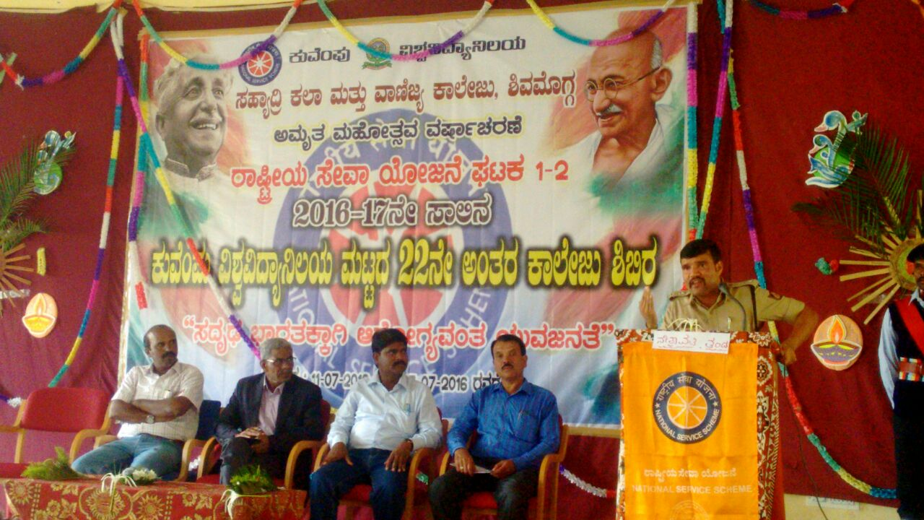

22 CAvÀgÀ PÁ¯ÉÃdÄ ²©gÀzÀ°è ¸ÀªÀiÁgÉÆÃ¥À ªÀiÁvÀÄUÀ¼À£ÀÄß DqÀÄwÛgÀÄªÀ ²ªÀªÉÆUÀÎ f¯Áè ¥ÉÆ°Ã¸ï ªÀÄÄRå¸ÀÜ ²æÃ gÀ« ZÉ£ÀßtÚ£ÀªÀgï

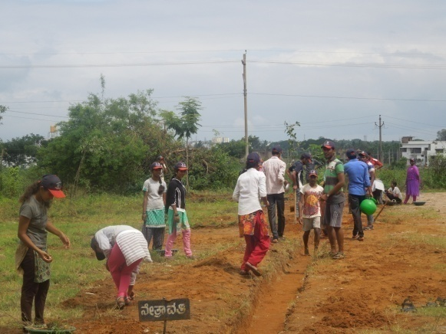

²©gÀzÀ°è ¸ÀºÁå¢æ ªÁtÂdå PÁ¯ÉÃfUÉ gÀ¸ÉÛ ªÀiÁqÀÄwÛgÀÄªÀ ²©gÁyðUÀ¼ÀÄ

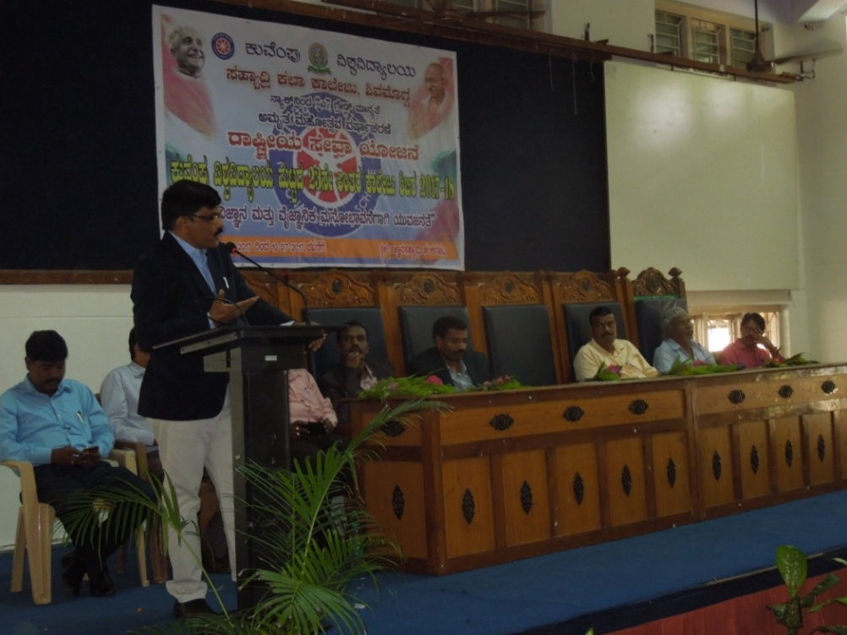

23 £ÉÃ CAvÀgÀ PÁ¯ÉÃdÄ ²©gÀ, PÀÄªÉA¥ÀÄ «±Àé«zÁå®AiÀÄ DªÀgÀt

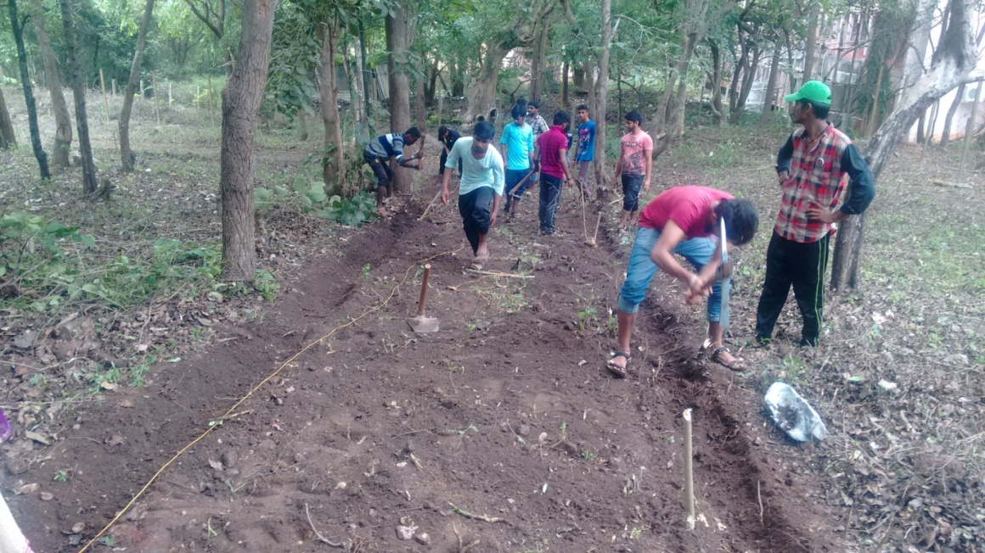
§mÁ¤PÀ¯ï UÁqÀð£ï ¤ªÀiÁðt : «±Àé«zÁå®AiÀÄ DªÀgÀt

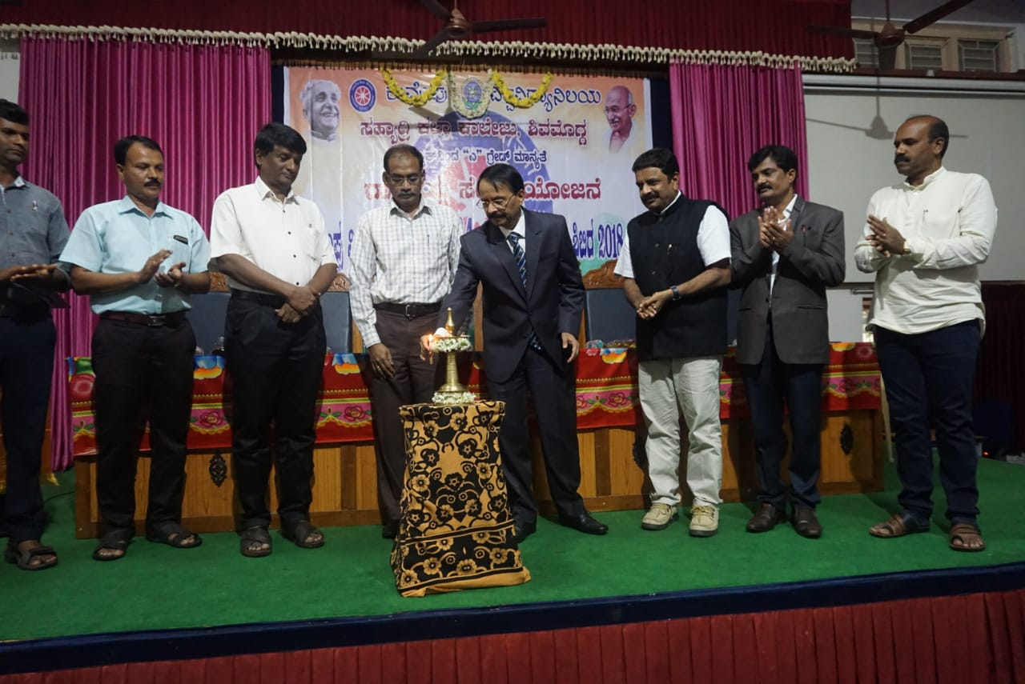

«±Àé«zÁå®AiÀÄ ªÀÄlÖzÀ 24£ÉÃ CAvÀgÀ PÁ¯ÉÃdÄ ²©gÀzÀ GzÁÏl£Á ¸ÀªÀiÁgÀA¨sÀ

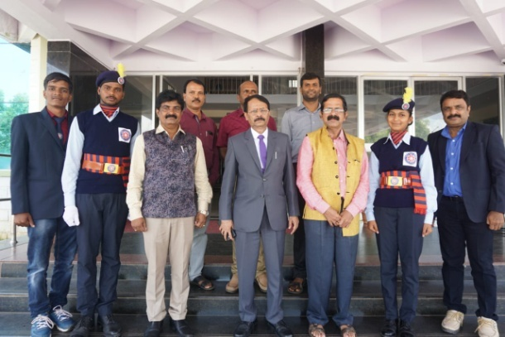
24 £ÉÃ CAvÀgÀ PÁ¯ÉÃdÄ ²©gÀzÀ°è ¨sÁUÀªÀ»¹zÀ CwyUÀ¼ÀÄ

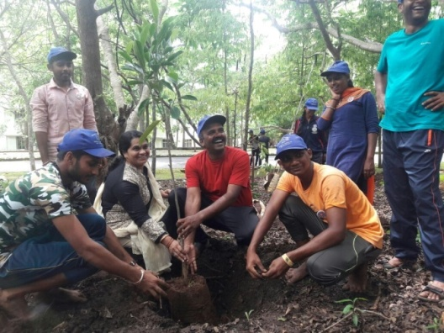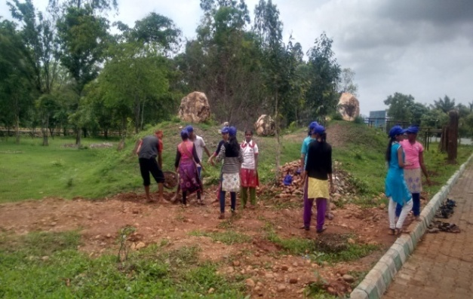
²©gÀzÀ ZÀlÄªÀnPÉAiÀÄ £ÉÆÃlUÀ¼ÀÄ

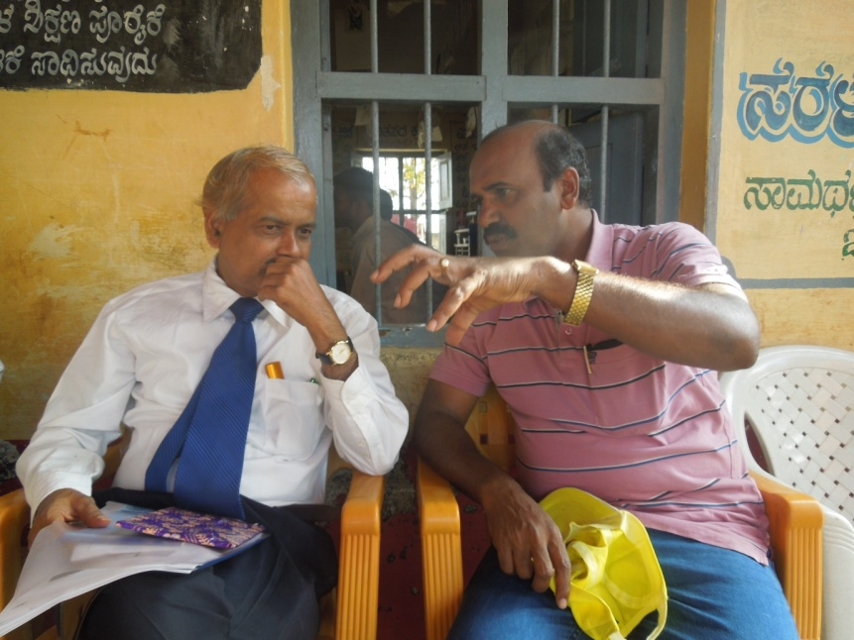
«±ÉÃµÀ ªÁ¶ðPÀ ²©gÀ zÉÆqÀØ ªÀÄvÀÛ° 2017 PÀÈ¶ «±Àé«zÁå®AiÀÄzÀ ªÀiÁ£Àå PÀÄ®¥ÀwUÀ¼ÁzÀ qÁ. JªÀiï PÉ £ÁAiÀÄÌ ¨sÁUÀªÀ»¹zÀÝgÀÄ

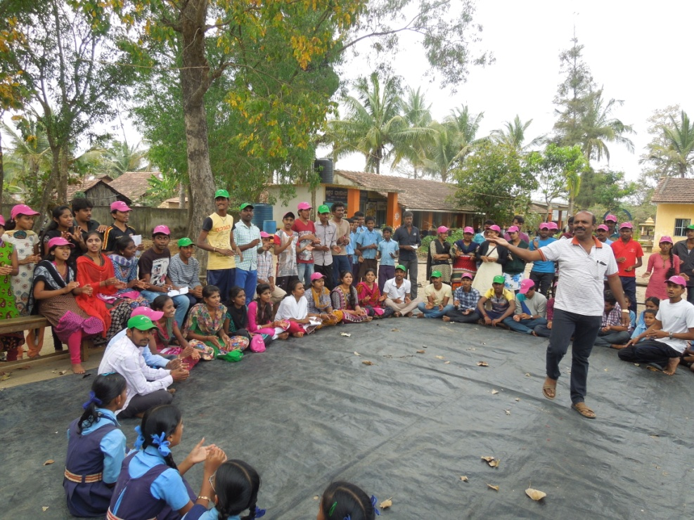

zÉÆqÀØ ªÀÄvÀÛ°AiÀÄ°è ©Ã¢ £ÁlPÀzÀ ¥ÀæzÀ±Àð£À

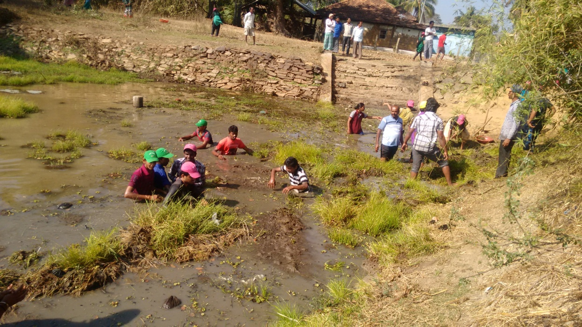

zÉÆqÀØªÀÄvÀÛ° UÁæªÀÄzÀ°è PÉgÉ ºÀÆ¼ÉwÛzÀ avÀæt

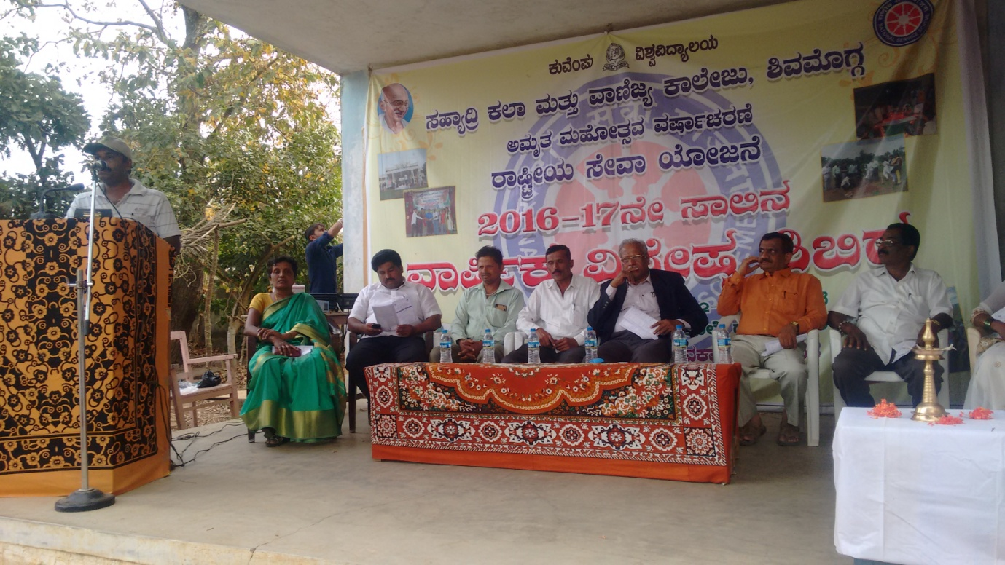

«±ÉÃµÀ ªÁ¶ðPÀ ²©gÀ zÉÆqÀØ ªÀÄvÀÛ° GzÁÏl£Á ¸ÀªÀiÁgÀA¨sÀ

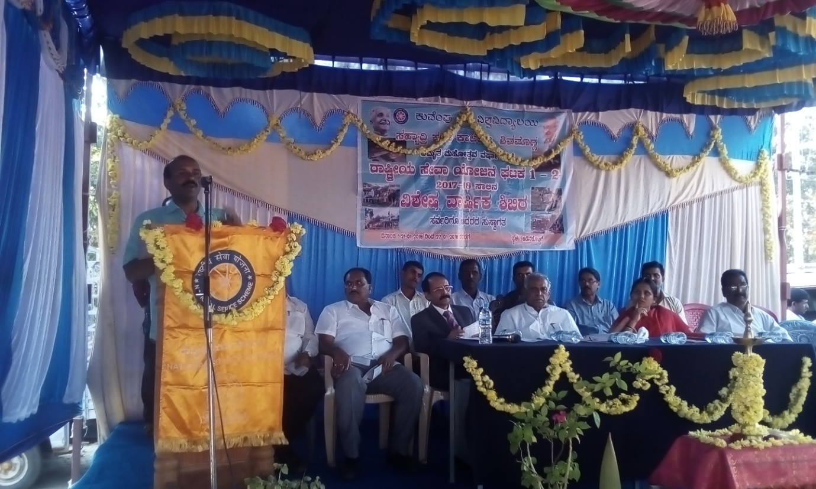
«±ÉÃµÀ ªÁ¶ðPÀ ²©gÀ Dr£ÀPÉÆnÖUÉ -2018 PÀAzÁAiÀÄ ¸ÀaªÀ ²æÃ PÁUÉÆÃqÀÄ wªÀÄä¥Àà£ÀªÀgÀÄ

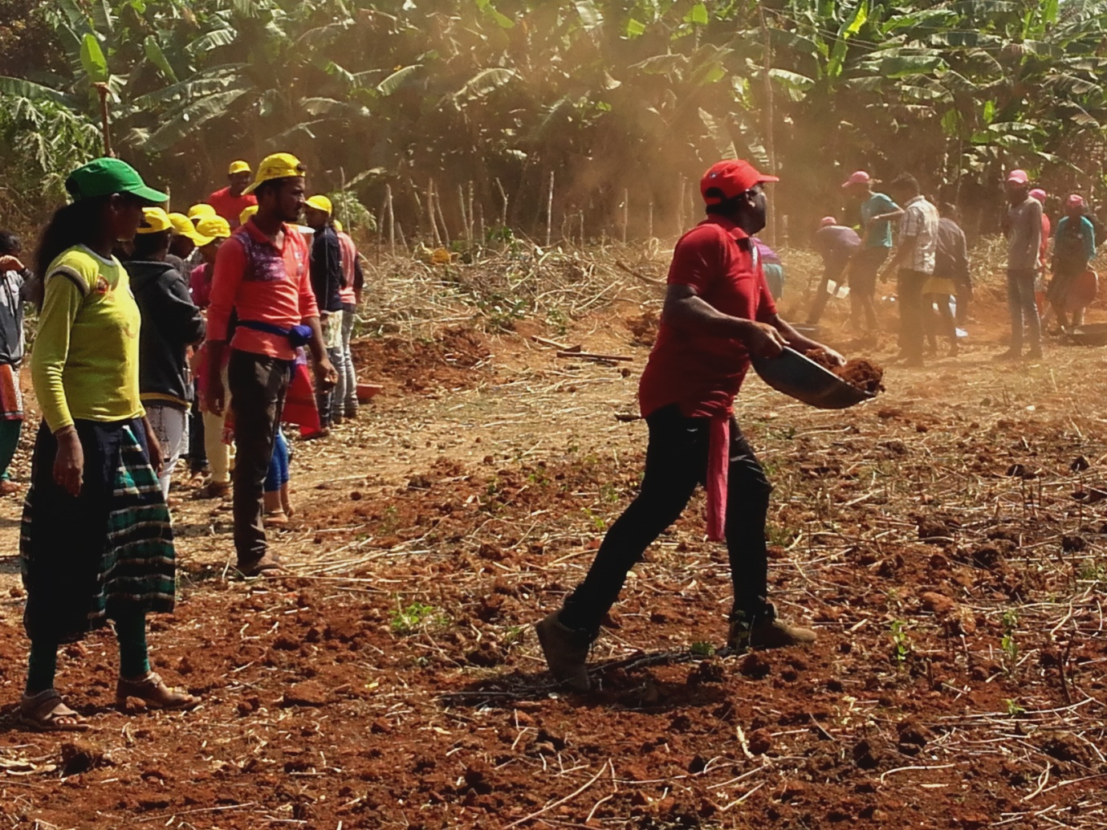
Dr£ÀPÉÆnÖUÉ ªÁ¶ðPÀ «±ÉÃµÀ ²©gÀzÀ ±ÀæªÀÄzÁ£ÀzÀ°è qÁ ªÉÆÃºÀ£À JZï J¸ï

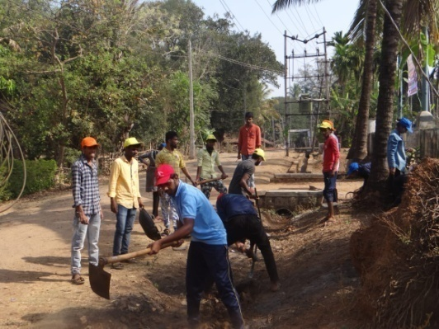

«±ÉÃµÀ ªÁ¶ðPÀ ²©gÀ-2019, gÉÃaPÉÆ¥Àà. ±ÀæªÀÄzÁ£ÀzÀ MAzÀÄ £ÉÆÃl

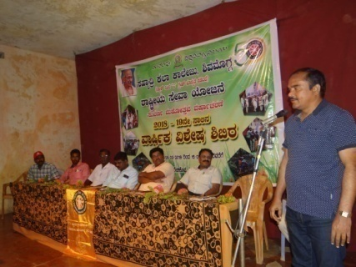
«±ÉÃµÀ ªÁ¶ðPÀ ²©gÀzÀ GzÁÏl£Á ¸ÀªÀiÁgÀA¨sÀ

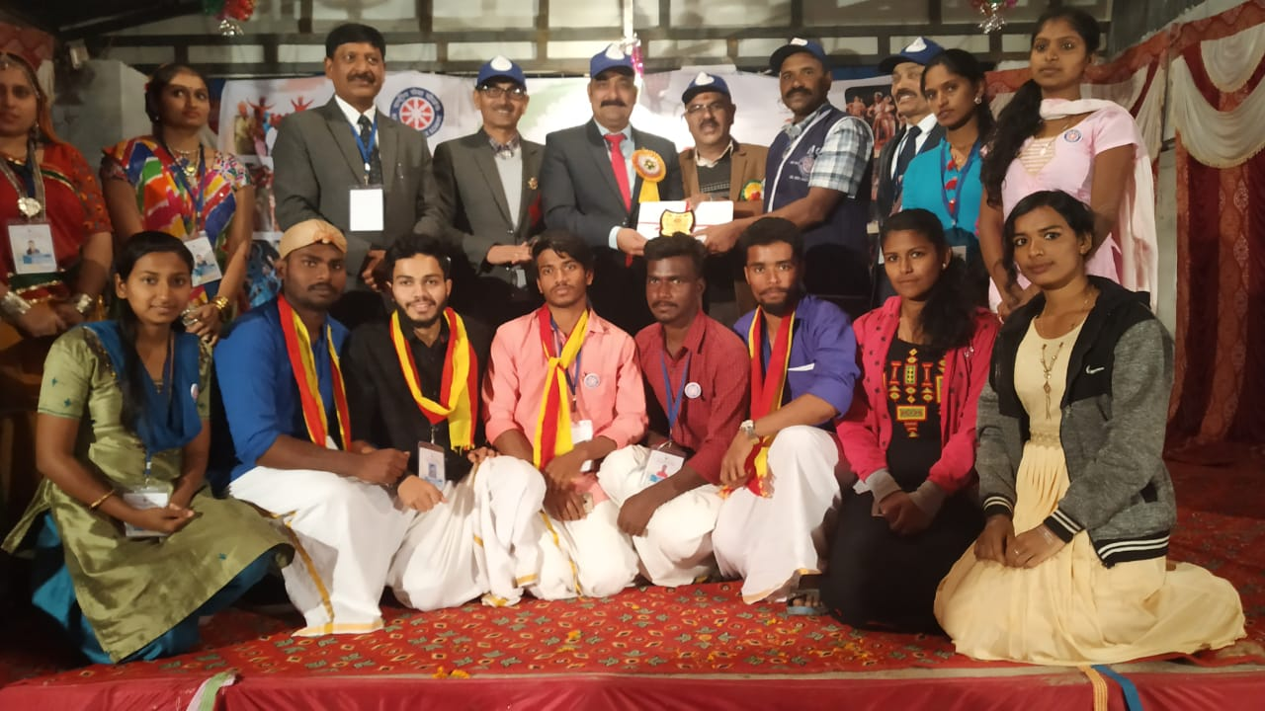
»ªÀiÁZÀ® ¥ÀæzÉÃ±ÀzÀ ªÀÄArAiÀÄ°è ¸ÀªÀÄUÀæ ¢éwÃAiÀÄ ¥Àæ±À¹Û

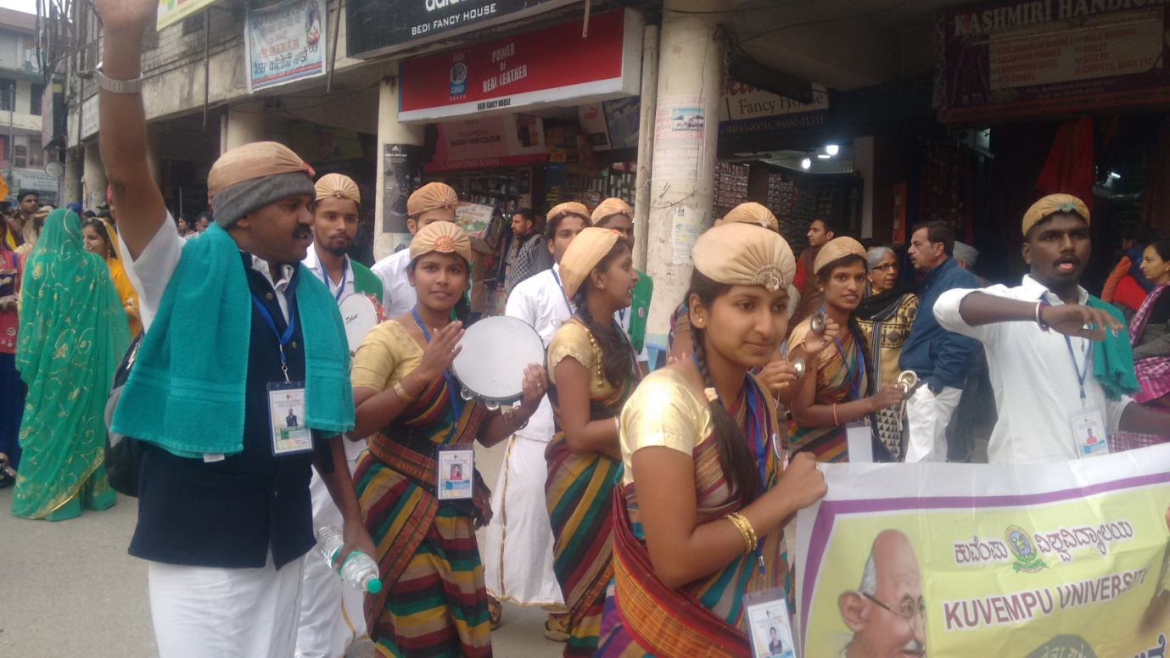
»ªÀiÁZÀ®¥ÀæzÉÃ±ÀzÀ ªÀÄArAiÀÄ°è £ÀqÉzÀ gÁ¶ÖçÃAiÀÄ ¨sÁªÉÊPÀåvÁ ²©gÀzÀ°è £ÀªÀÄä «±Àé«zÁå®AiÀÄzÀ vÀAqÀ, C¢üPÁjAiÀiÁV qÁ ªÉÆÃºÀ£À JZï J¸ï

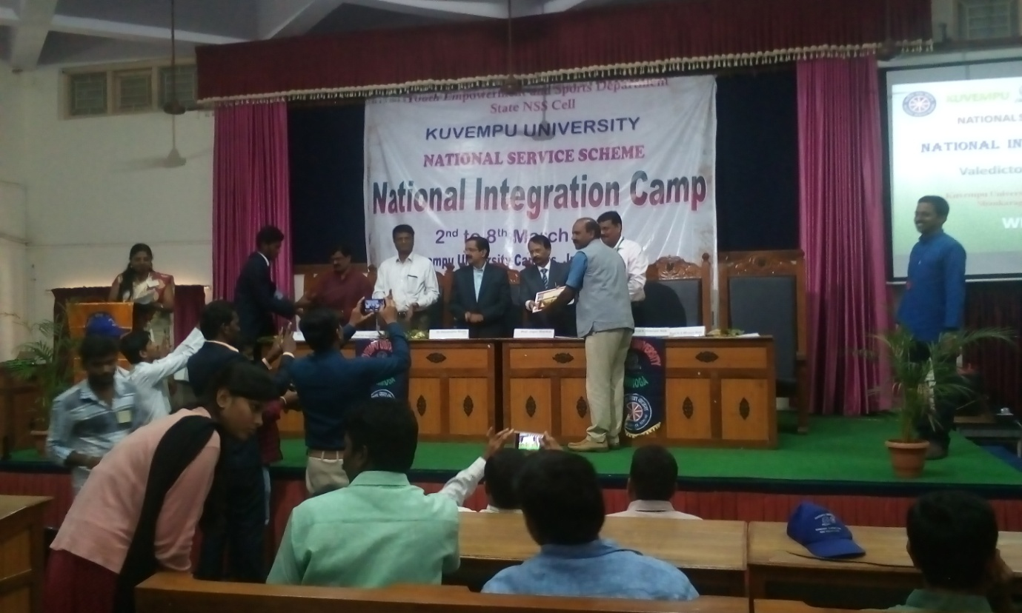

gÁ¶ÖçÃAiÀÄ ¨sÁªÉÊPÀåvÁ ²©gÀ- PÀÄªÉA¥ÀÄ «±Àé«zÁå®AiÀÄ

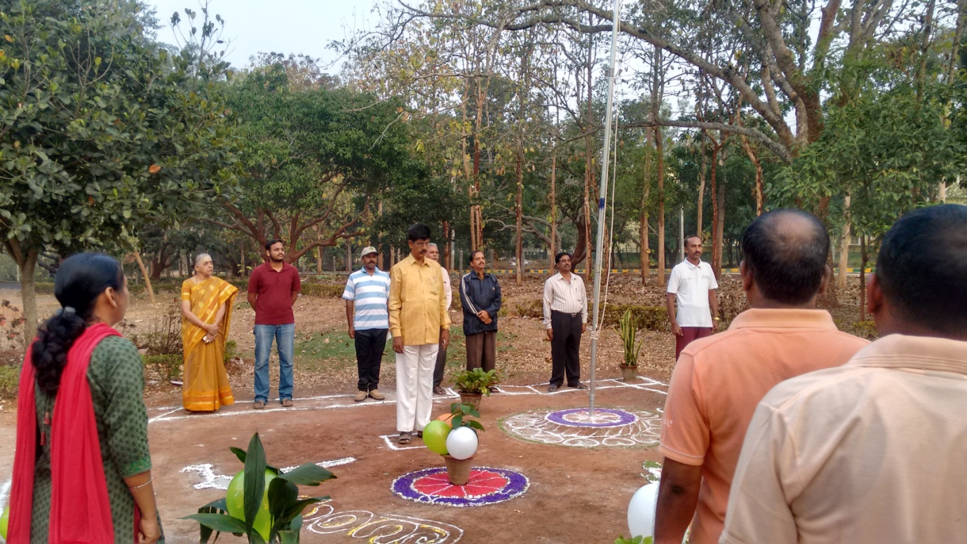

gÁ¶ÖçÃAiÀÄ ¸ÉÃªÁ AiÉÆÃd£Á C¢üPÁjUÀ¼À vÀgÀ¨ÉÃw- ªÉÄÊ¸ÀÆgÀÄ
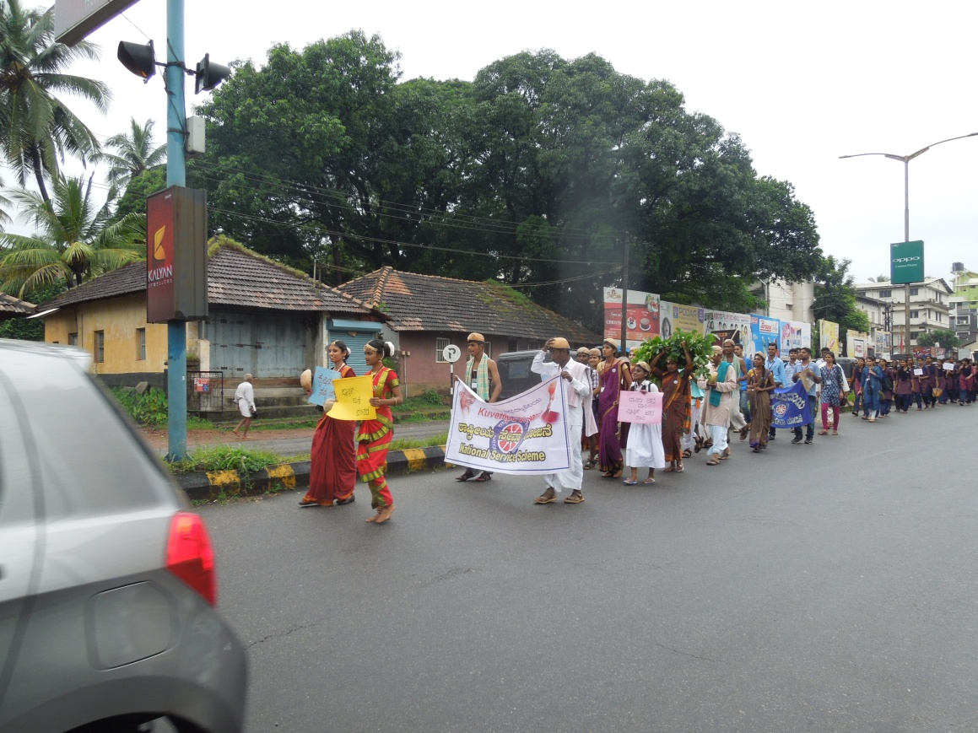
gÁdå ªÀÄlÖzÀ AiÀÄÄªÀd£ÉÆÃvÀìªÀ GqÀÄ¦-2017 ¨sÁªÉÊPÀåvÁ ªÉÄgÀªÀtÂUÉ

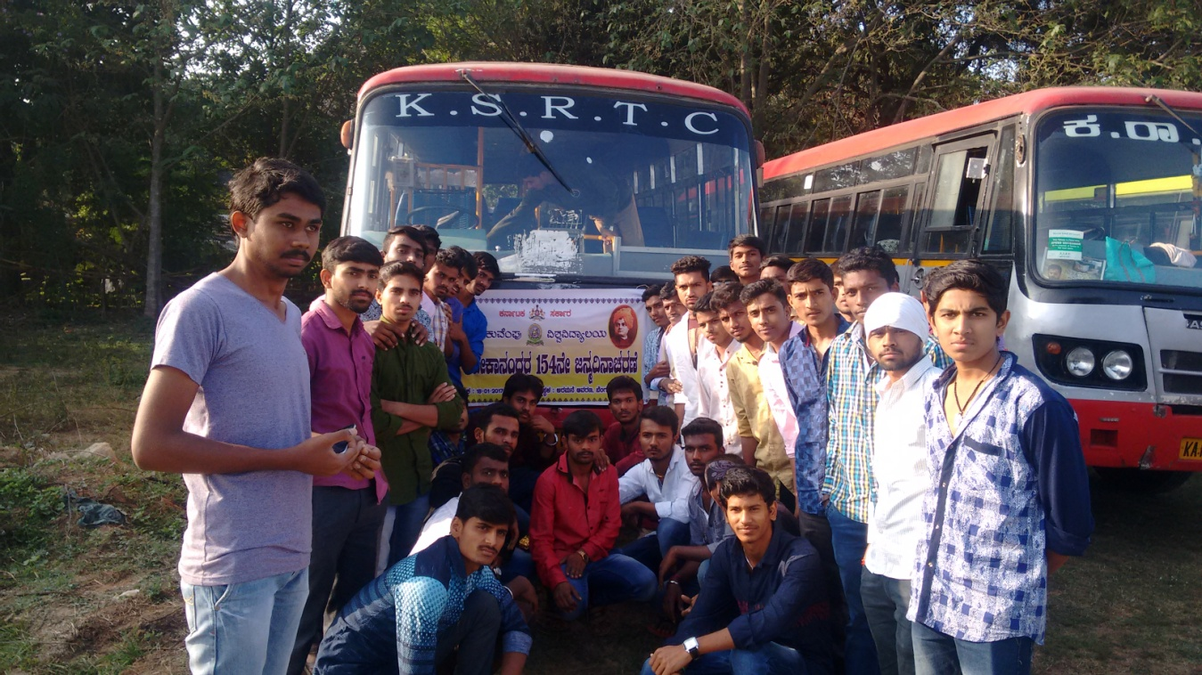
¢£ÁAPÀ: 18/01/2017gÀ°è ¨ÉAUÀ¼ÀÆj£À CgÀªÀÄ£É ªÉÄÊzÁ£ÀzÀ°è £ÀqÉzÀ ¸Áé«Ä «ªÉÃPÁ£ÀAzÀ dAiÀÄAwAiÀÄ°è £ÀªÀÄä PÁ¯ÉÃf£À 50 d£À «zÁåyðUÀ¼ÀÄ ¨sÁUÀªÀ»¹zÀÝgÀÄ

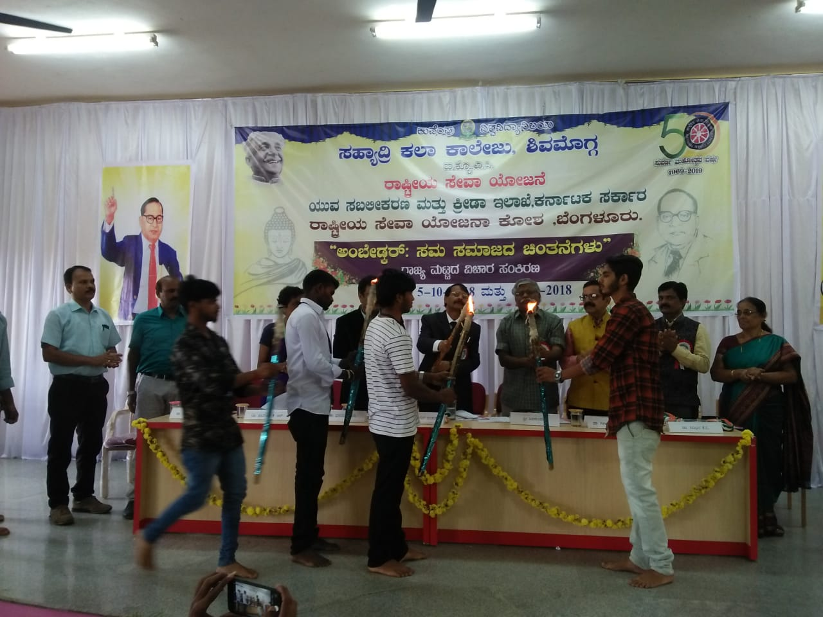
CA¨ÉÃqÀÌgï ;¸ÀªÀÄ¸ÀªÀiÁdzÀ PÀ£À¸ÀÄ.JgÀqÀÄ ¢£ÀUÀ¼À gÁdå ªÀÄlÖzÀ «ZÁgÀ ¸ÀAQgÀt GzÁÏl£Á ¸ÀªÀiÁgÀA¨sÀ

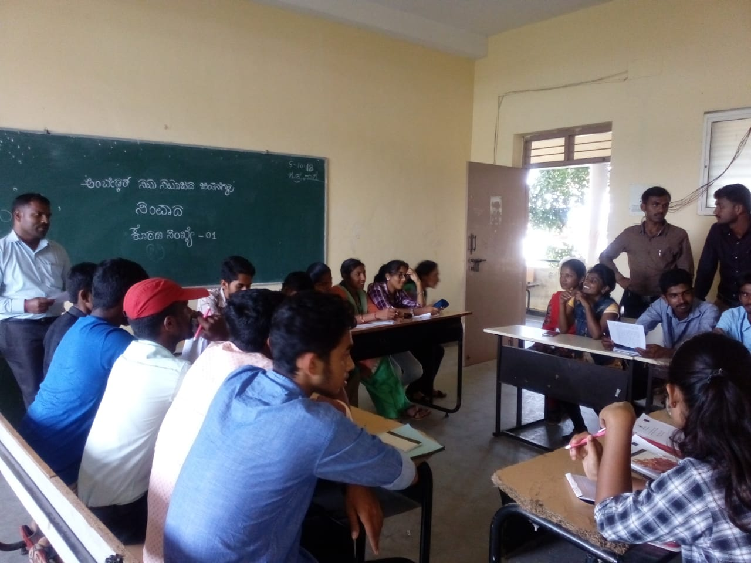

«ZÁgÀ ¸ÀAQgÀtzÀ°è UÀÄA¥ÀÄ ZÀZÉðUÉ DzÀåvÉ

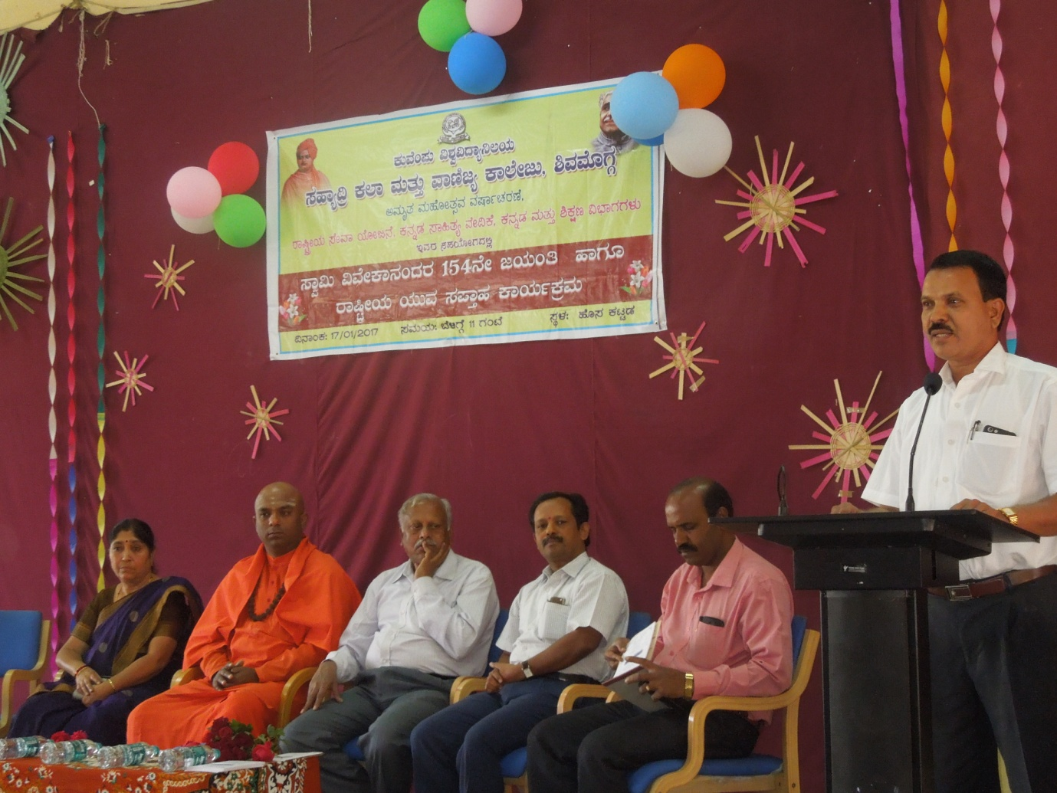

¢£ÁAPÀ 17-01-2017gÀAzÀÄ £ÀqÉzÀ ¸Áé«Ä «ªÉÃPÁ£ÀAzÀ dAiÀÄAw

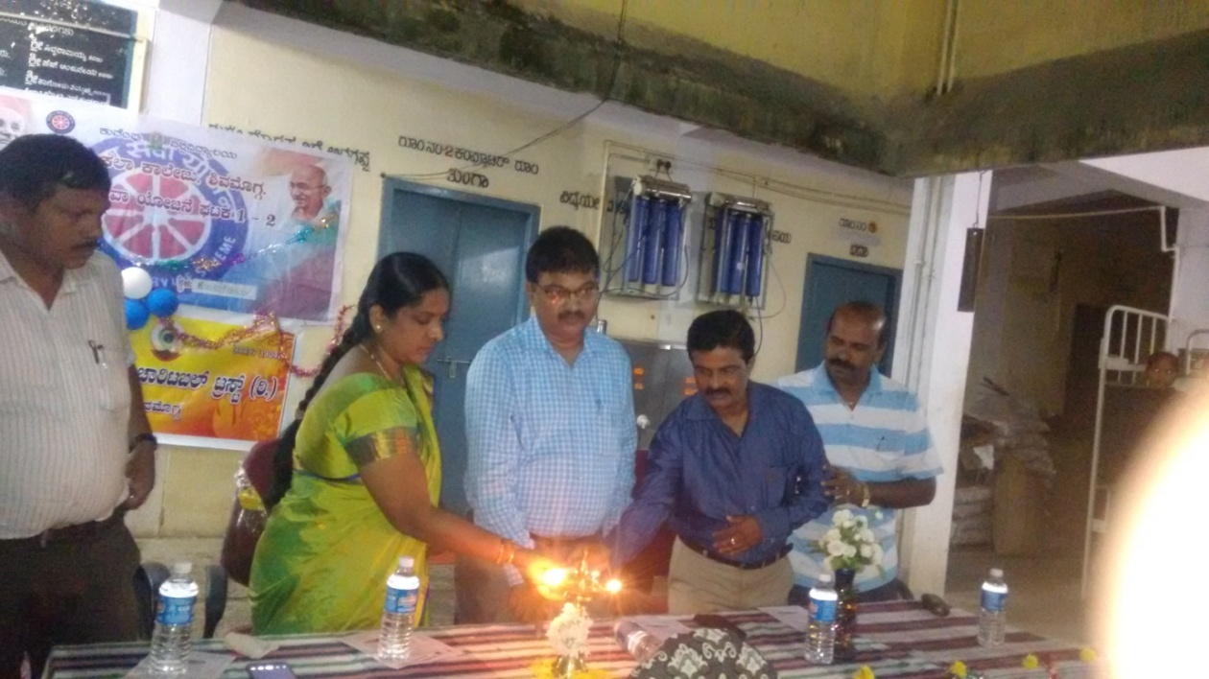
¸ÀºÁå¢æ PÀ¯Á PÁ¯ÉÃf£À C©üAiÀiÁ£À- «zÁåyð¤¤®AiÀÄzÀ°è DgÉÆÃUÀå –CjªÀÅ PÁgÀåPÀæªÀÄ

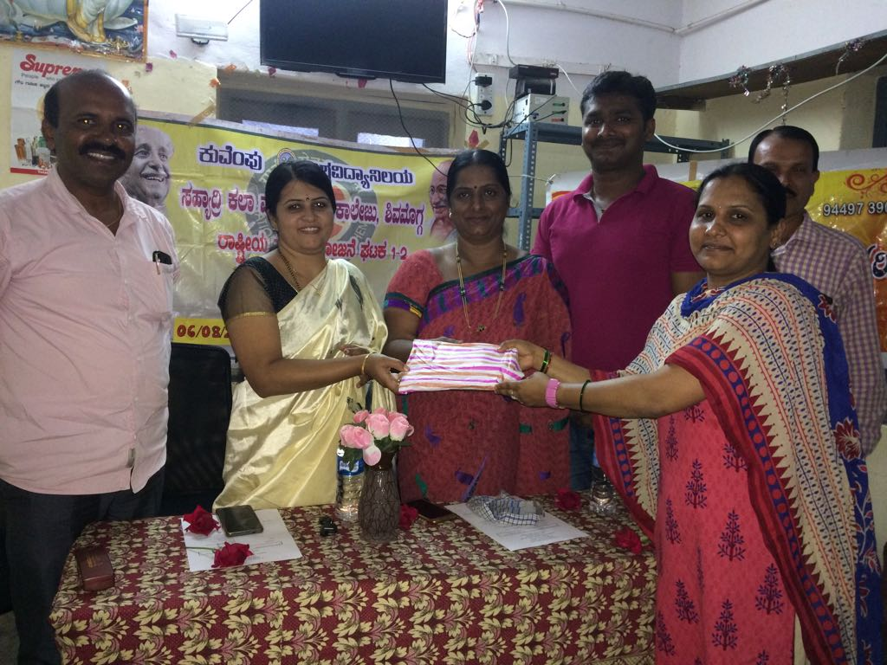

¸ÀºÁå¢æ PÀ¯Á PÁ¯ÉÃf£À C©üAiÀiÁ£À- «zÁåyð¤¤®AiÀÄzÀ°è DgÉÆÃUÀå –CjªÀÅ PÁgÀåPÀæªÀÄ

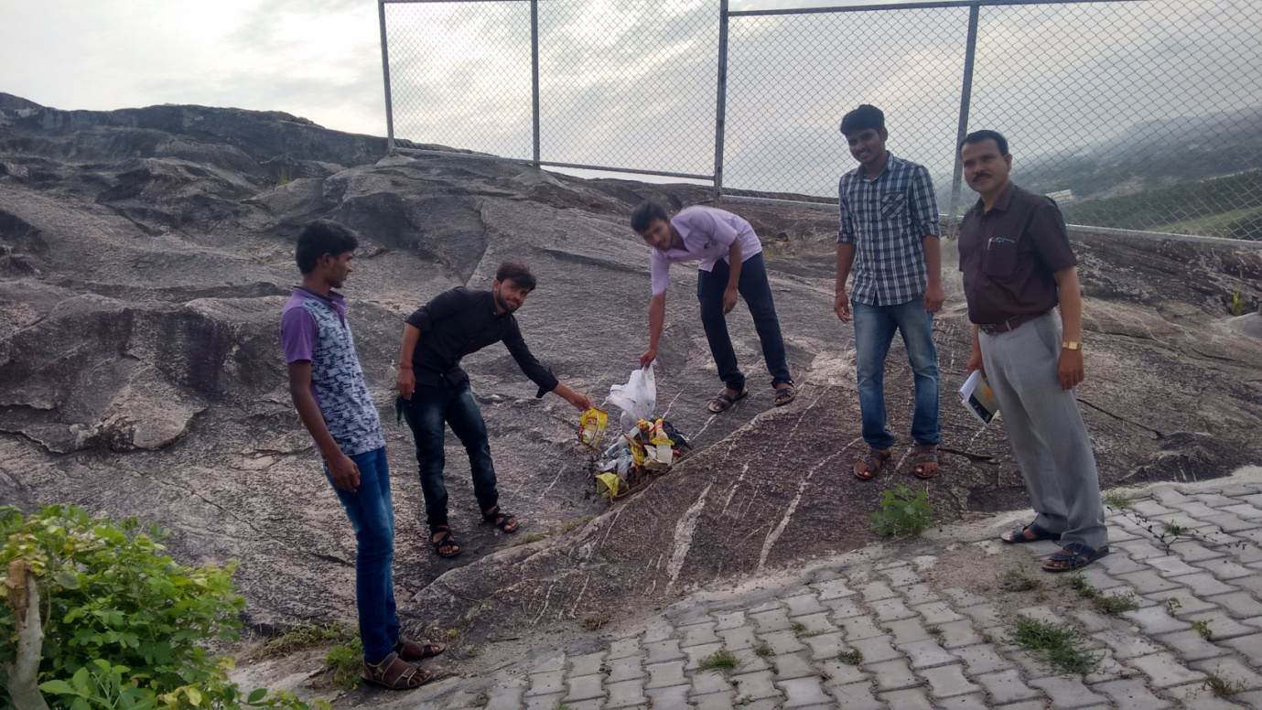

zÀvÀÄÛ UÁæªÀÄzÀ°è ¥Áè¹ÖPï ¤ªÀÄÆð®£À C©üAiÀiÁ£À ²ªÀªÉÆUÀÎ

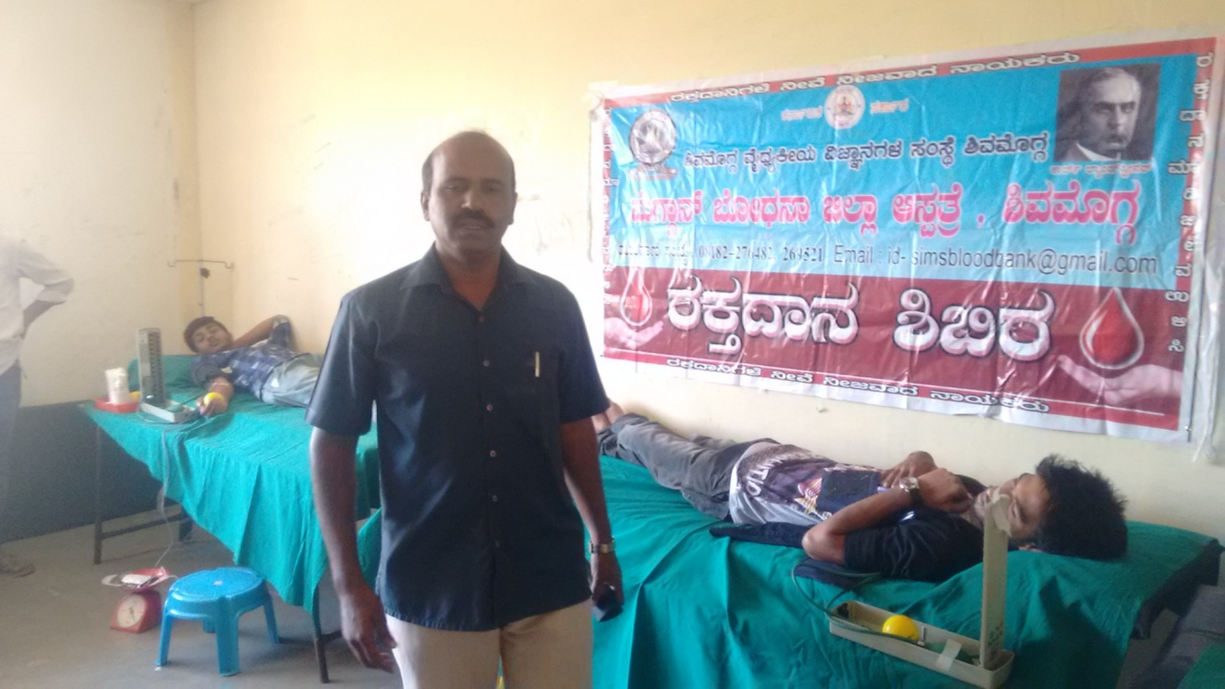
gÀPÀÛzÁ£À ²©gÀ ¸ÀºÁå¢æ PÀ¯Á PÁ¯ÉÃdÄ ²ªÀªÉÆUÀÎ
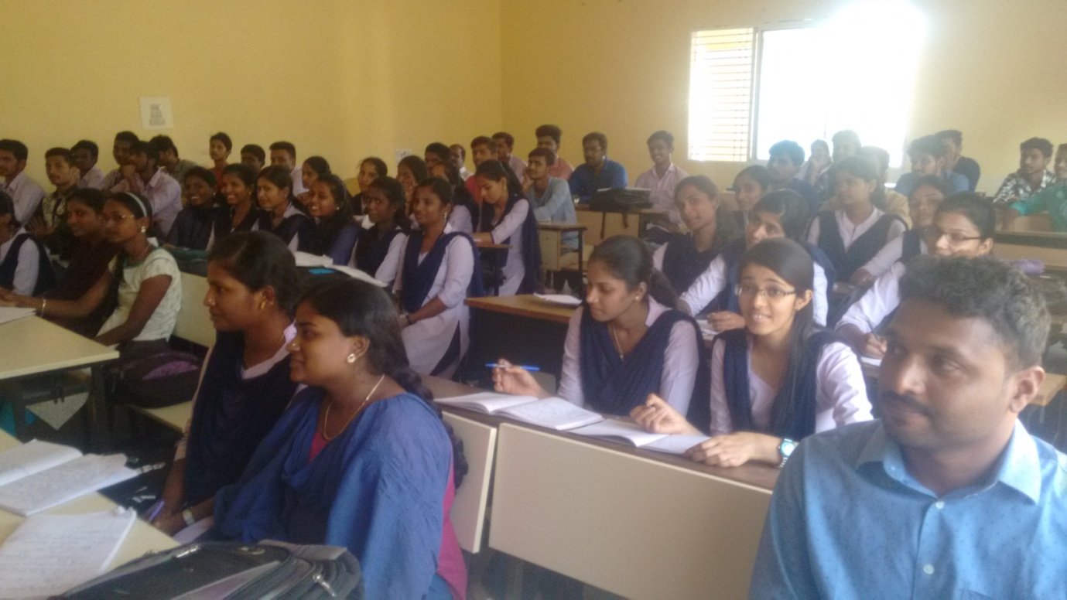
CaÃªÀgïì PÉÆÃaAUï ¸ÉAlgï CªÀgÀ ¸ÀºÀAiÉÆÃUÀzÉÆA¢UÉ ¸ÀàzsÁðvÀäPÀ ¥ÀjÃPÉëUÀ¼À PÉÆÃaAUï PÁåA¥ï

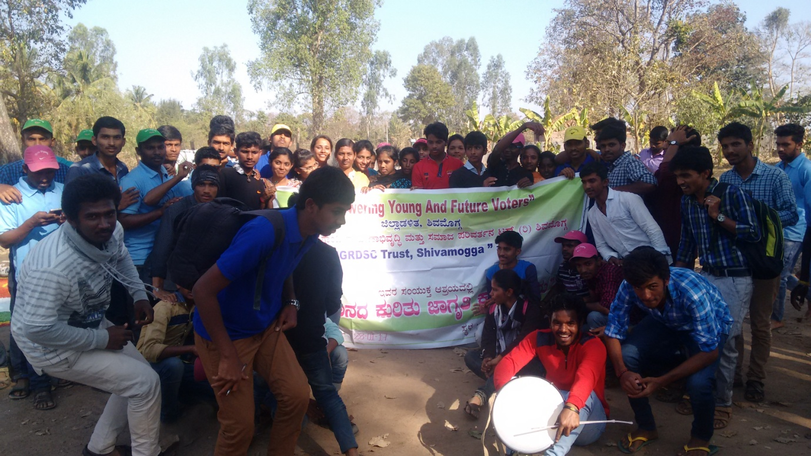

ªÀÄvÀzÁ£À eÁUÀÈw ªÉÄgÀªÀtÂUÉ

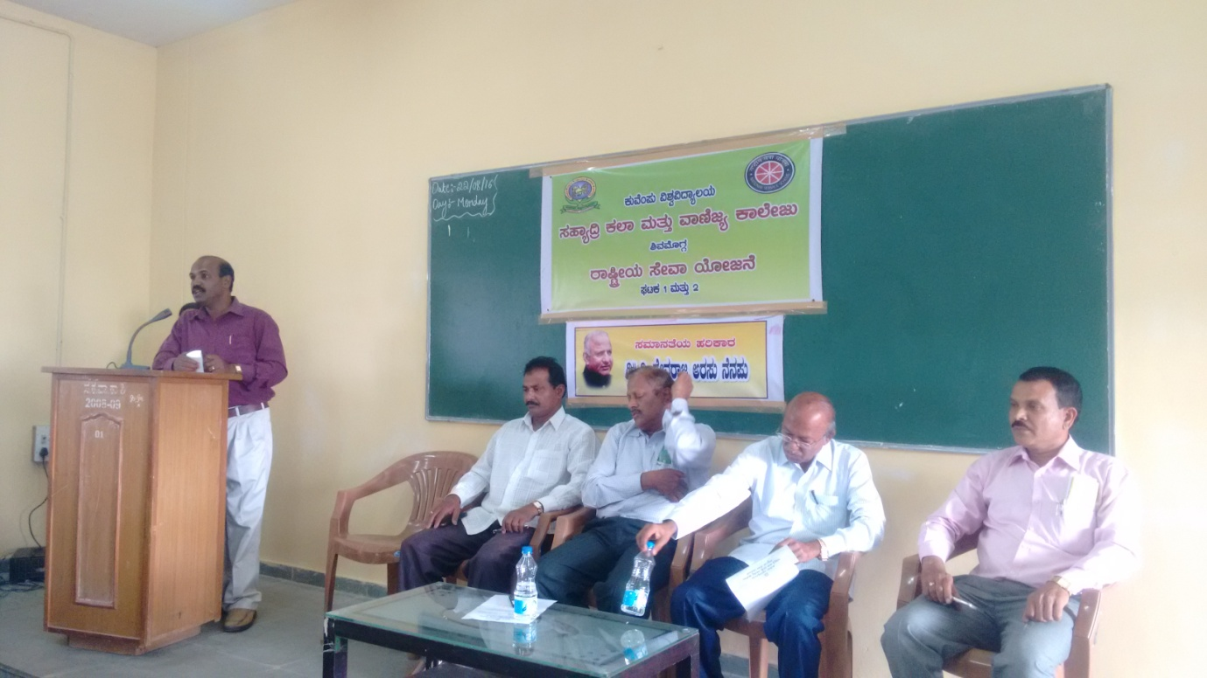
zÉÃªÀgÁd CgÀ¸ÀÄ £É£À¥ÀÄ PÁgÀåPÀæªÀÄ-qÁ ¸ÀtÚgÁªÀÄ ªÀiÁ£Àå ¥ÁæzsÁå¥ÀPÀgÀÄ PÀÄªÉA¥ÀÄ «±Àé«zÁå®AiÀÄ

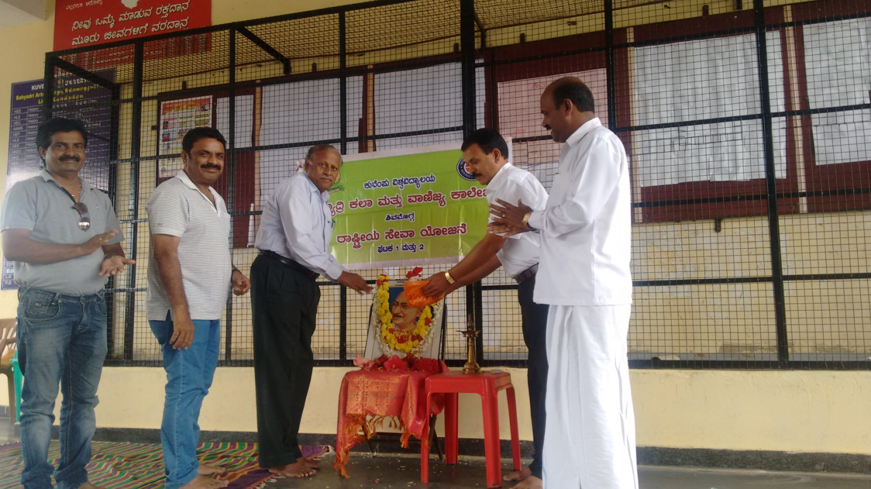

UÁA¢ü dAiÀÄAw PÁgÀåPÀæªÀÄ

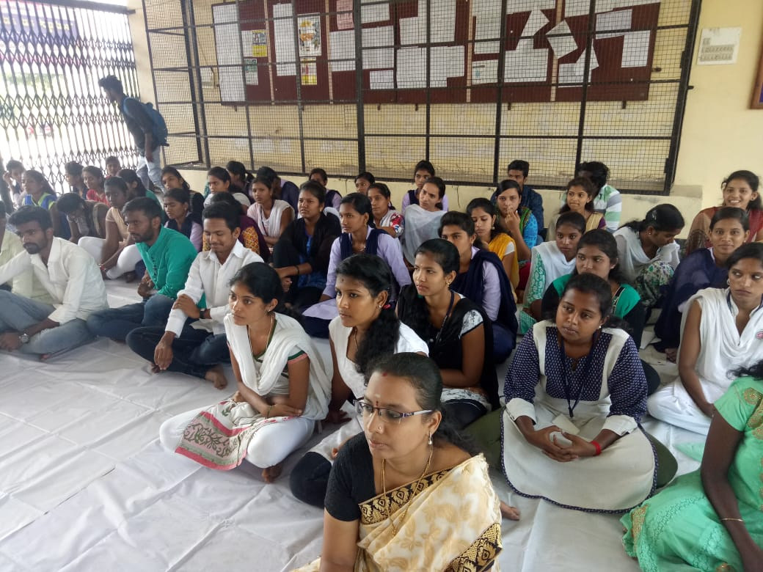

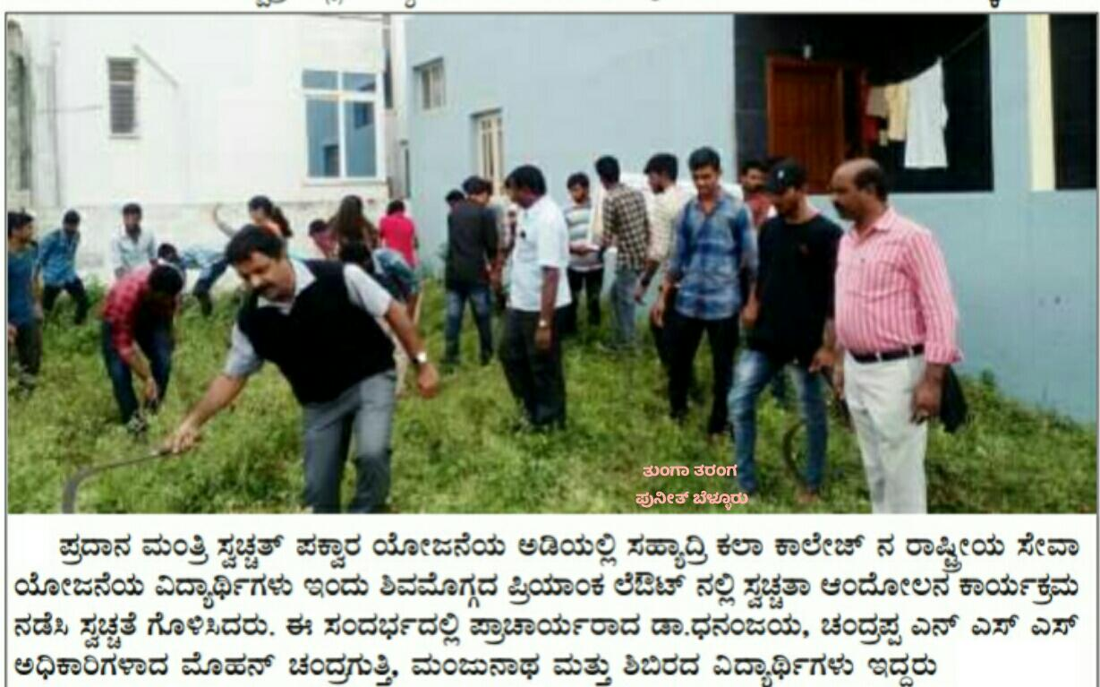

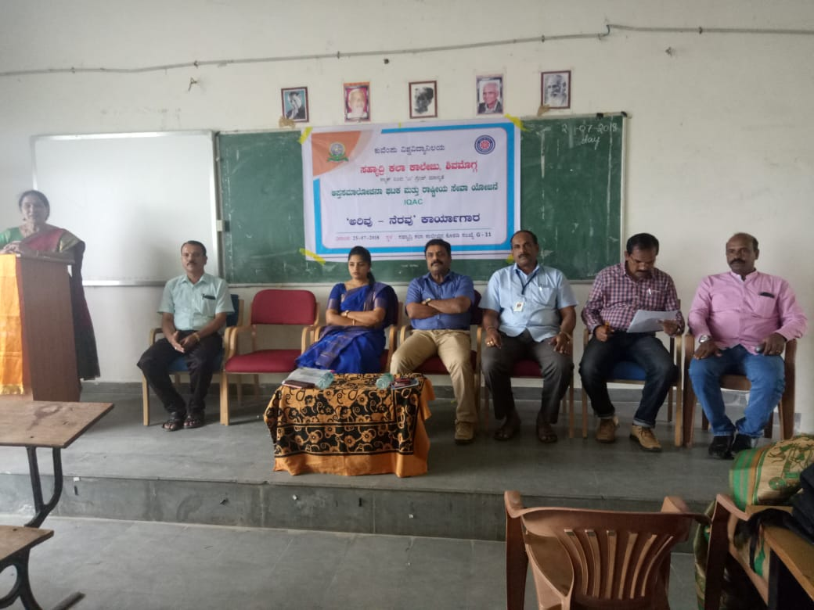

«zÁåyð¤AiÀÄjUÉ «±ÉÃµÀ vÀgÀ¨ÉÃw,CjªÀÅ-£ÉgÀªÀÅ PÁgÀåPÀæªÀÄ. ºÀ¢ºÀgÉAiÀÄzÀ ¸ÀªÀÄ¸ÉåUÀ¼ÀÄ

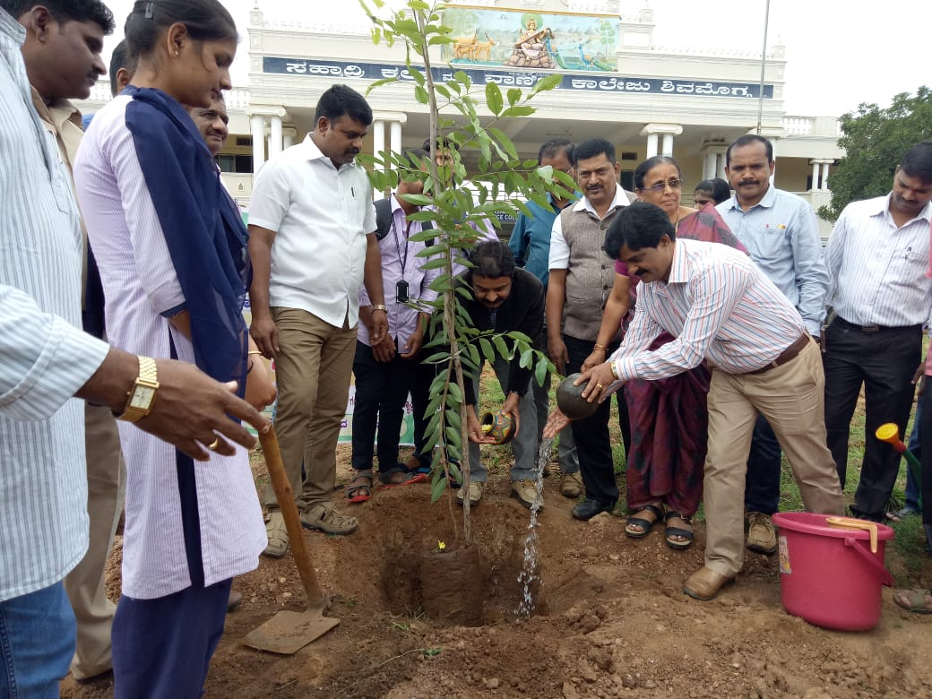

2018-19 £ÉÃ ¸Á°£À «±ÉÃµÀ PÁgÀåPÀæªÀÄ. ºÀ¹gÀÄ PÁåA¥À¸ï-£ÀªÀÄä PÁåA¥À¸ï AiÉÆÃd£ÉAiÀÄ GzÁÏl£Á ¸ÀªÀiÁgÀA¨sÀ
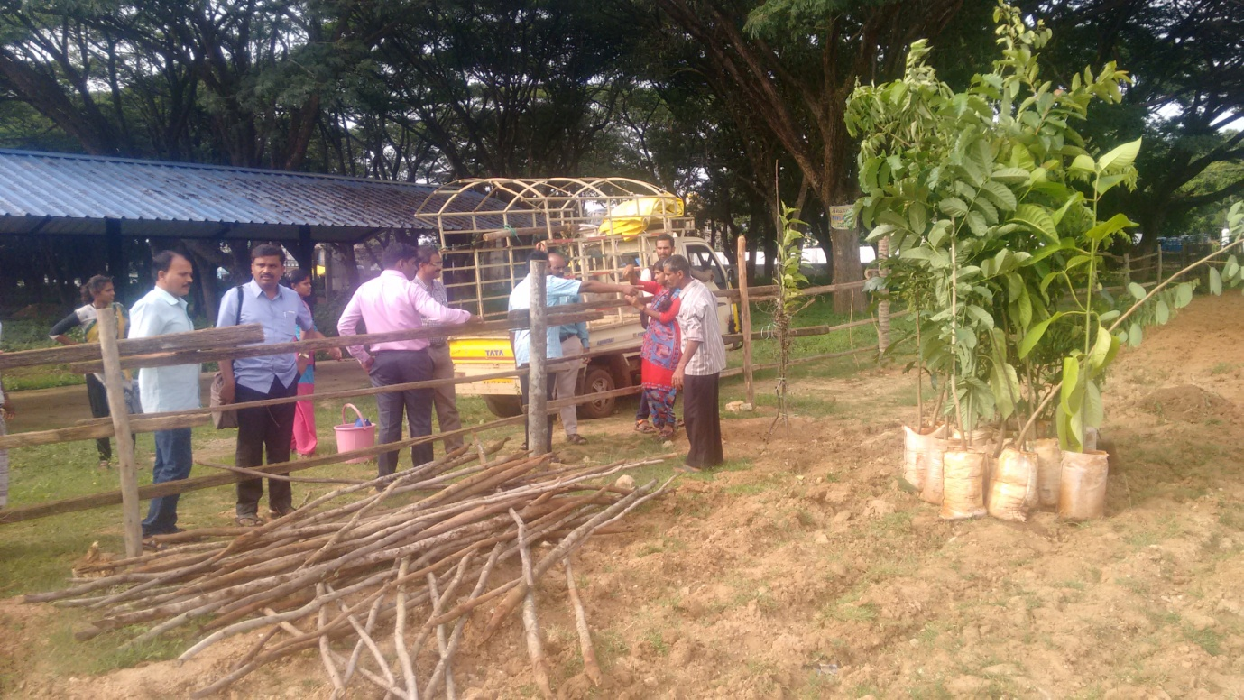
ºÀ¹gÀÄ PÁåA¥À¸ï- £ÀªÀÄä PÁåA¥À¸ï PÁgÀåPÀæªÀÄPÉÌ ¨sÀÆ«ÄAiÀÄ£ÀÄß ¸ÀdÄÓ ªÀiÁrPÉÆ¼ÀÄîwÛgÀÄªÀÅzÀÄ.

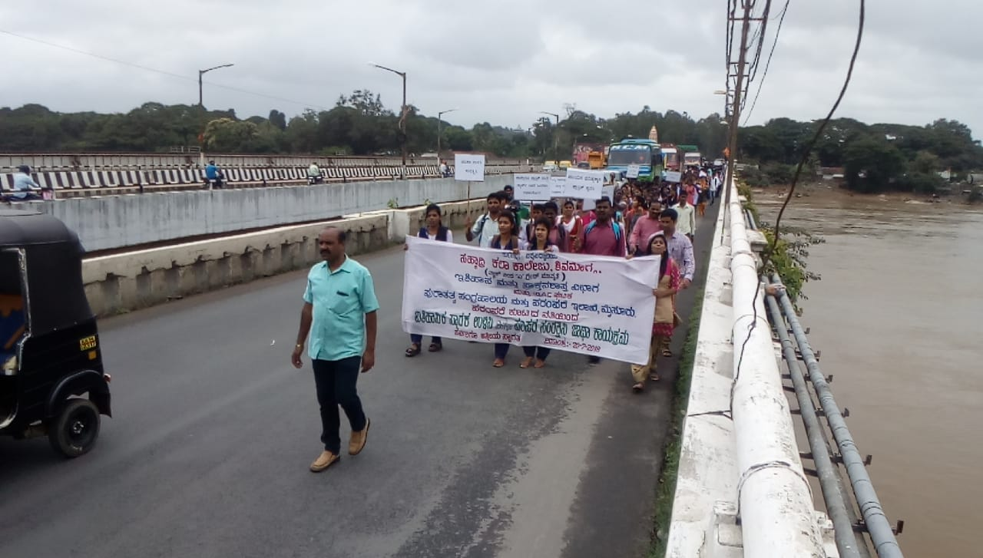

¥ÁæZÀå ªÀ¸ÀÄÛ G½¹ C©üAiÀiÁ£ÀzÀrAiÀÄ°è ²ªÀ¥Àà£ÁAiÀÄPÀ CgÀªÀÄ£ÉAiÀÄ ¸ÀéZÀÒvÉ ªÀÄvÀÄÛ ªÉÄgÀªÀtÂUÉ.

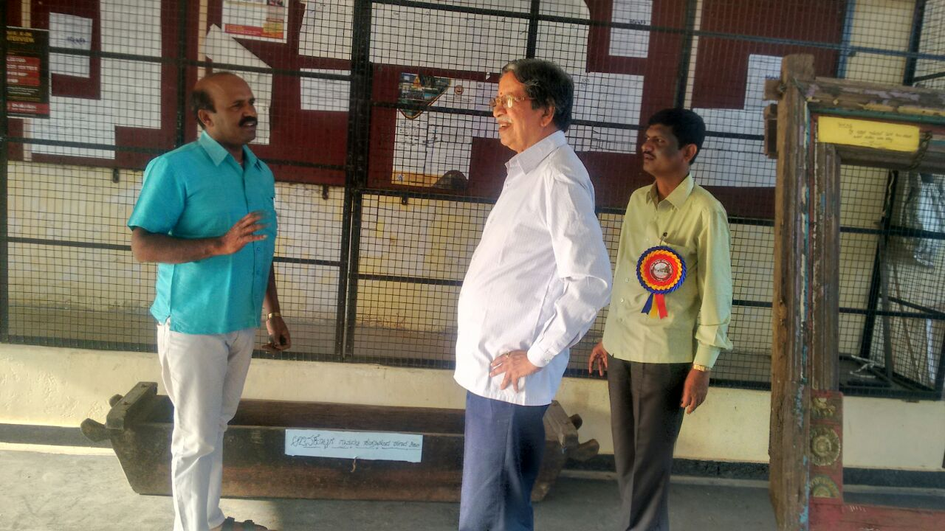

gÁ¶ÖçÃAiÀÄ ¸ÉÃªÁ AiÉÆÃd£ÉAiÀÄ ªÀ¸ÀÄÛ ¸ÀAUÀæºÁ®AiÀÄPÉÌ ¨sÉÃn ¤Ãr ªÀ¸ÀÄÛUÀ¼À£ÀÄß «ÃQë¹zÀ qÁ £Ár¸ÉÆÃd

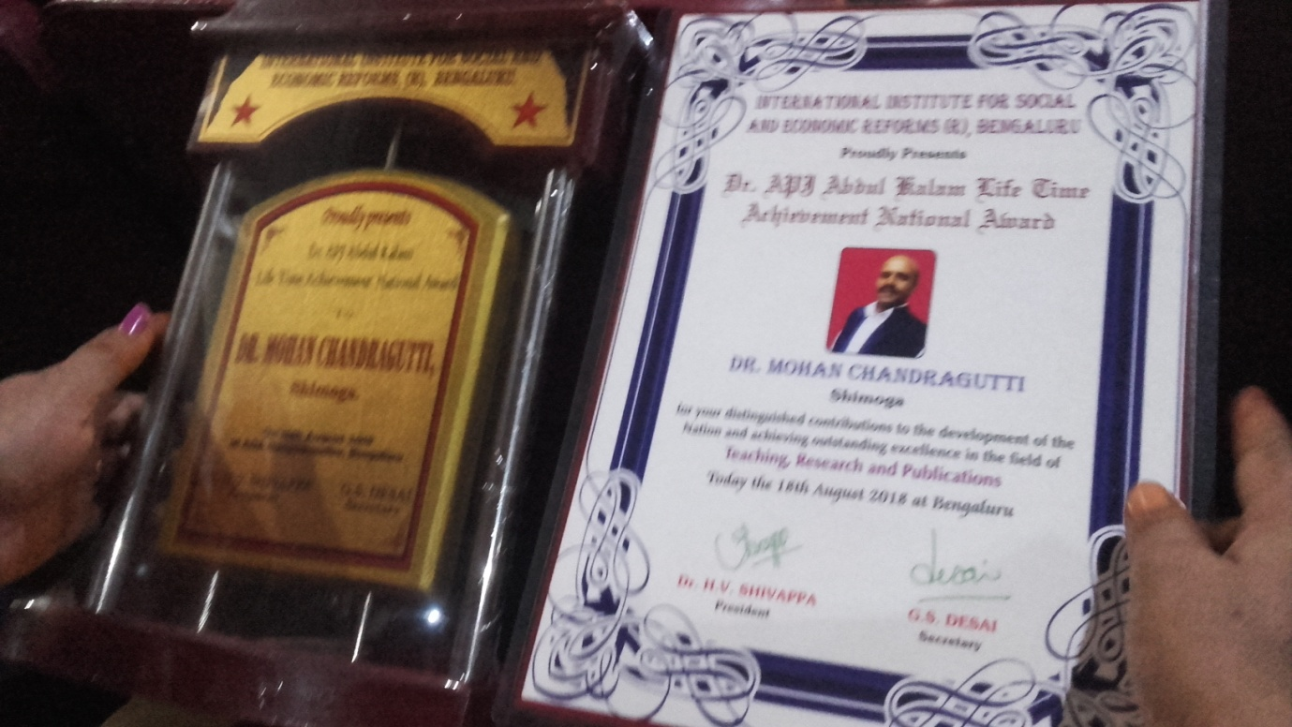
J¦eÉ C§ÄÝ¯ï PÀ¯ÁªÀiï CaÃªÀgïì gÁ¶ÖçÃAiÀÄ ¥Àæ±À¹Û
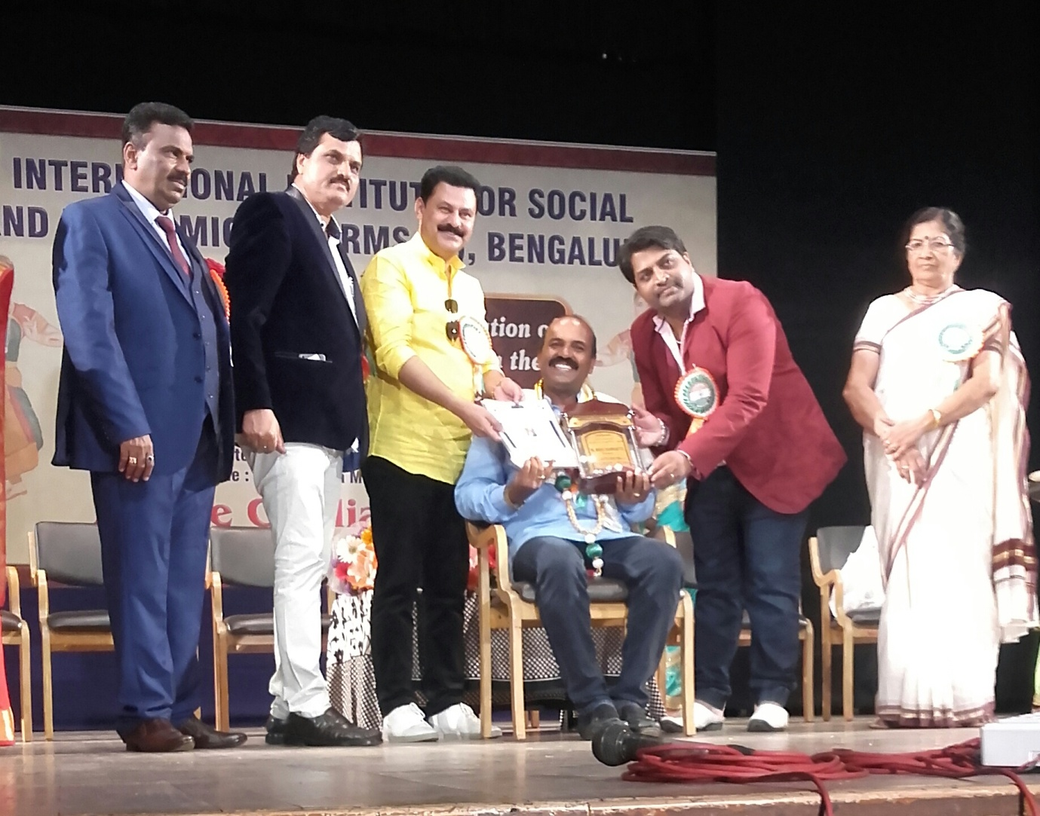

¥Àæ±À¹Û ¥ÀæzsÁ£À ¸ÀªÀiÁgÀA¨sÀ

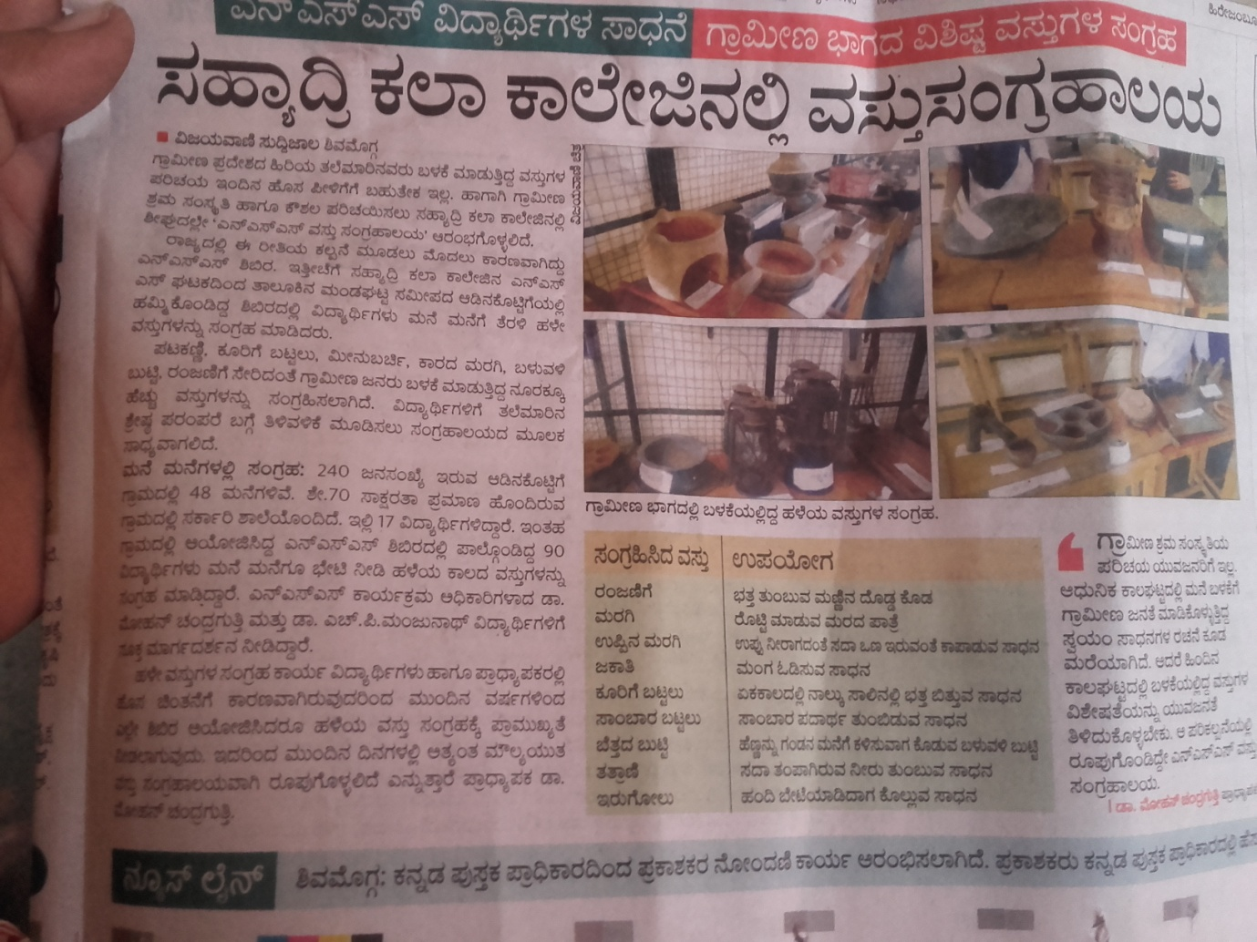

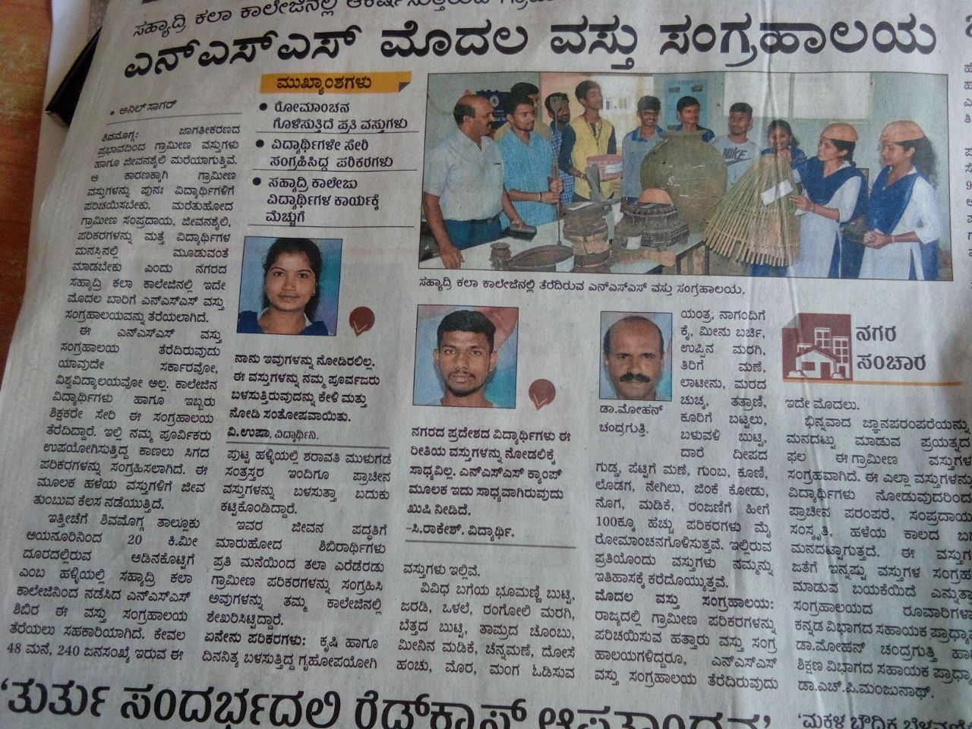
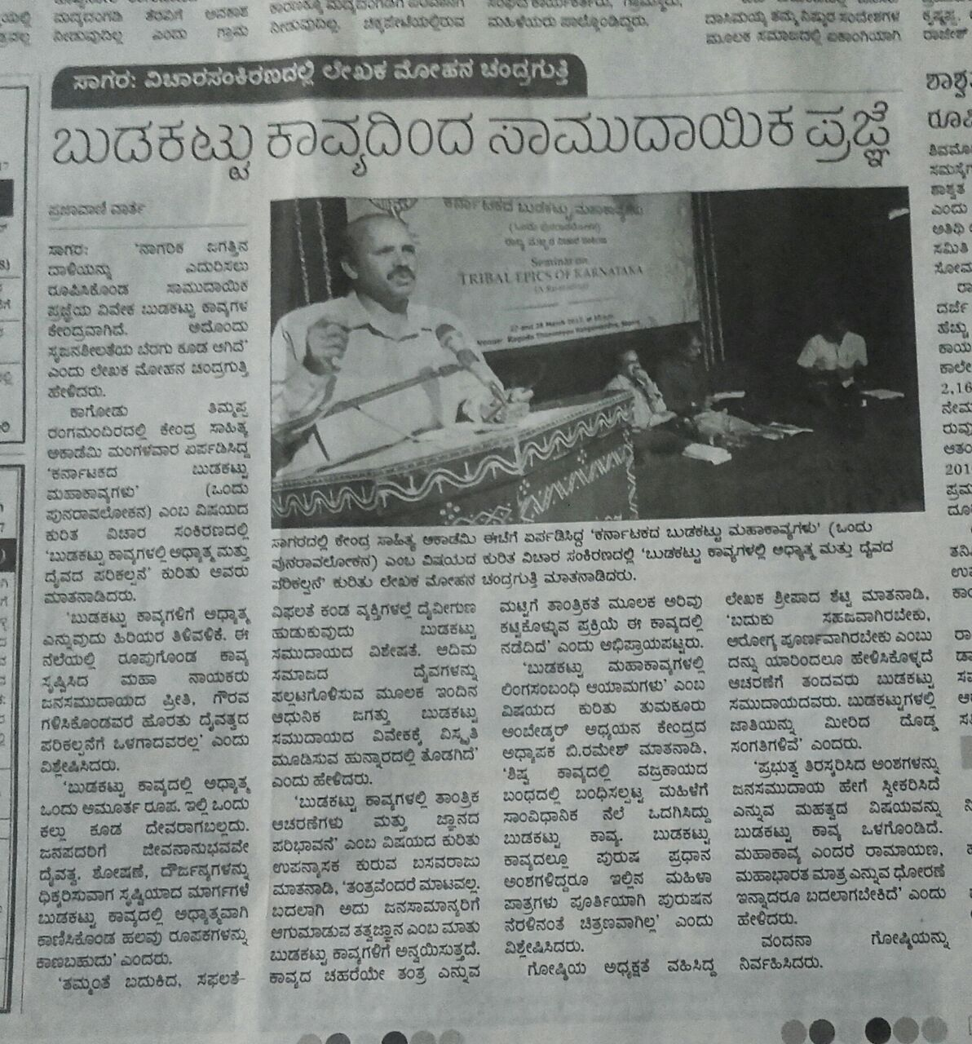
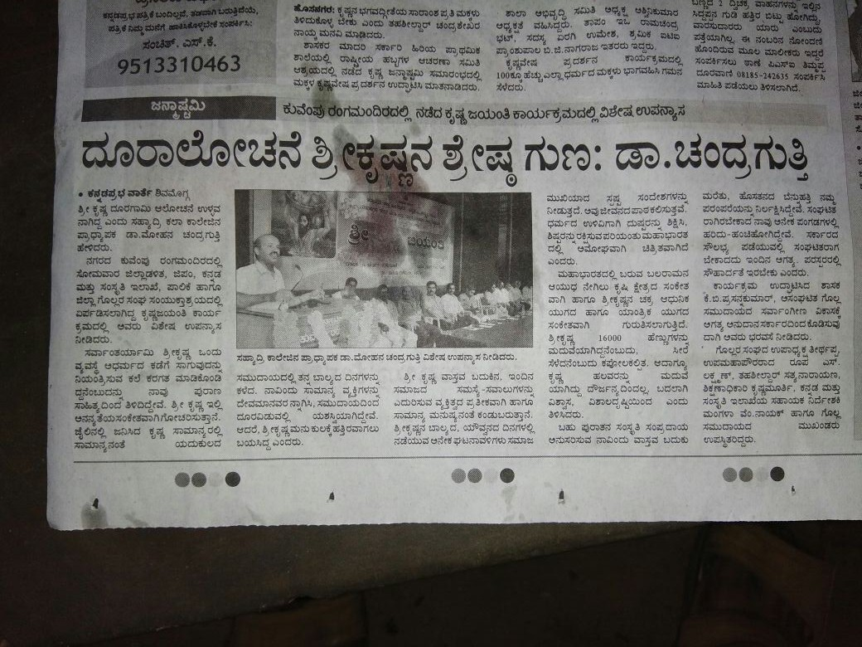

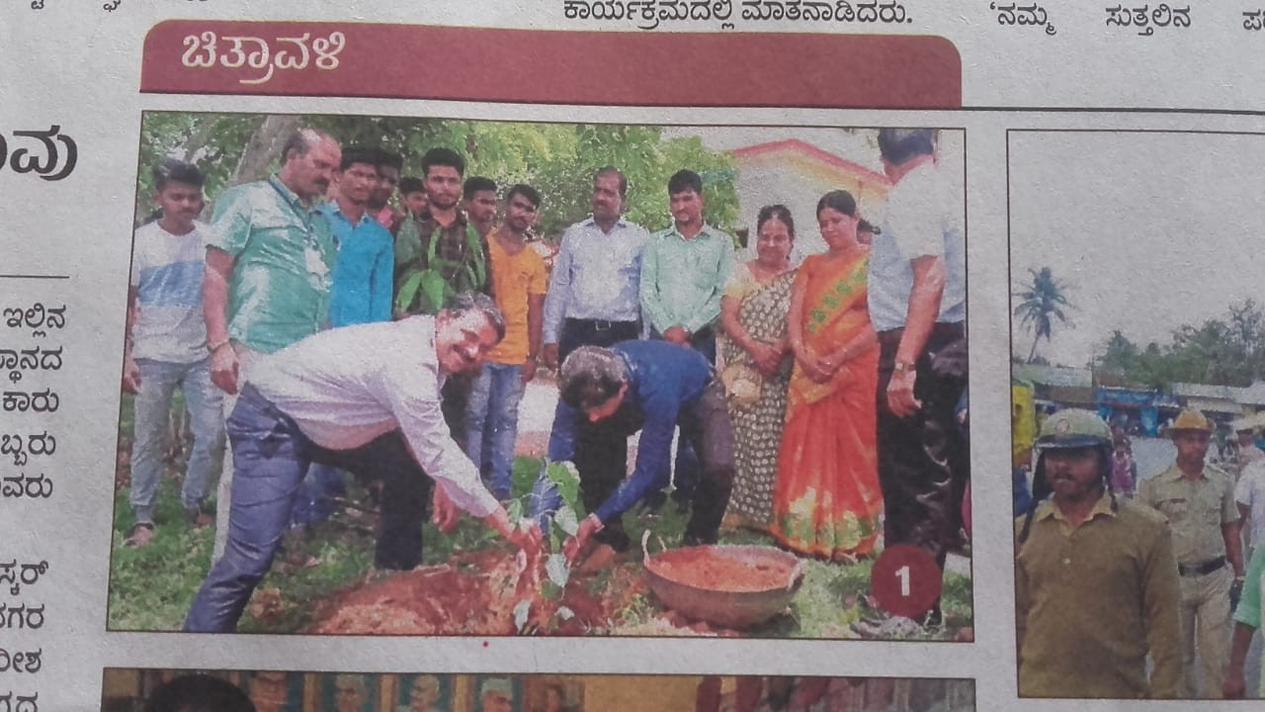

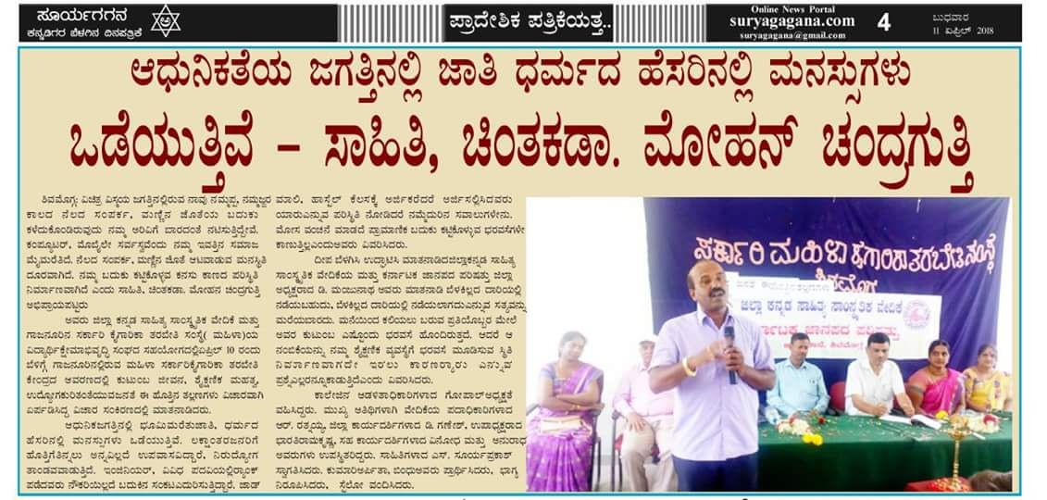

¸ÀºÀ¨sÁVvÀé M¥ÀàAzÀ ¥ÀvÀæ

G¥À¸ÀAgÀPÀëuÁ¢üPÁjUÀ¼ÀÄ
¸ÁªÀiÁfPÀ CgÀtå AiÉÆÃd£É
²ªÀªÉÆUÀÎ G¥À «¨sÁUÀ
ªÀÄvÀÄÛ ¥ÁæZÁAiÀÄðgÀÄ
¸ÀºÁå¢æ PÀ¯Á PÁ¯ÉÃdÄ ²ªÀªÉÆUÀÎ
ªÉÄÃ®ÌAqÀ «¼Á¸ÀzÁgÀgÁzÀ £ÁªÀÅUÀ¼ÀÄ dAnAiÀiÁV WÉÆÃµÀuÉ ªÀiÁrPÉÆ¼ÀÄîªÀÅzÉÃ£ÉazÀgÉ ¸ÀºÁå¢æ PÁ¯ÉÃf£À DªÀgÀtzÀ°è CgÀtåªÀ£ÀÄß ¨É¼É¸ÀÄªÀ ºÉÆuÉAiÉÆA¢UÉ ¸ÀÄªÀiÁgÀÄ 60 VqÀUÀ¼À£ÀÄß £ÉqÀ®Ä M¥ÀàAzÀ ªÀiÁrPÉÆArzÉÝÃªÉ. «±Àé«zÁå®AiÀÄPÉÌ AiÀiÁªÀ DyðPÀ ºÉÆgÉ¬Ä®èzÉ gÁ¸ÉÃAiÉÆÃ ¸ÀéAiÀÄA¸ÉÃªÀPÀgÀ £ÉgÀªÀÅ ºÁUÀÆ ¸ÁC« EªÀgÀ ¸ÀºÀPÁgÀzÉÆA¢UÉ VqÀ ¨É¼É¸ÀÄªÀ AiÉÆÃd£ÉaiÀÄ£ÀÄß ºÀ«ÄäPÉÆArzÉÝÃªÉ. ªÀÄÄA¢£À ¢£ÀUÀ¼À°è §gÀÄªÀ DyðPÀ DzÁAiÀÄªÀ£ÀÄß «±Àé«zÁå®AiÀÄPÉÌ ¤ÃqÀÄªÀ PÀgÁj£ÉÆA¢UÉ F M¥ÀàAzÀ ªÀiÁrPÉÆ¼Àî¯ÁVzÉ.
ªÀazÀ£ÉUÀ¼ÉÆA¢UÉ
vÀªÀÄä «±Áé¹UÀ¼ÀÄ

¸ÀºÀ¨sÁVvÀé M¥ÀàAzÀ
¤zÉÃð±ÀPÀgÀÄ
CaÃªÀgïì ¸ÀàzsÁðvÀäPÀ ¥ÀjÃPÉëUÀ¼À vÀgÀ¨ÉÃw ¸ÀA¸ÉÜ
²ªÀªÉÆUÀÎ
ªÀÄvÀÄÛ
¥ÁæZÁAiÀÄðgÀÄ
¸ÀºÁå¢æ PÀ¯Á PÁ¯ÉÃdÄ ²ªÀªÉÆUÀÎ

ªÉÄÃ®ÌaqÀ «¼Á¸ÀzÁgÀgÁzÀ £ÁªÀÅ 2017 £ÉÃ E¹é¬ÄazÀ ªÀÄÄA¢£À ªÀÄÆgÀÄ ªÀµÀðUÀ¼À PÁ® «±Àé«zÁå®AiÀÄPÉÌ AiÀiÁªÀ DyðPÀ ºÉÆgÉ E®èzÉ ¸ÀºÁå¢æ PÁ¯ÉÃf£À gÁ ¸ÉÃAiÉÆÃ ¸ÀéAiÀÄA¸ÉÃªÀPÀjUÉ ¸ÀàzsÁðvÀäPÀ ¥ÀjÃPÉëUÀ¼À vÀgÀ¨sÉÃwAiÀÄ£ÀÄß PÁ®PÁ®PÉÌ ¤ÃqÀÄªÀ M¥ÀàAzÀªÀ£ÀÄß ªÀiÁrPÉÆArzÉÝÃªÉ.CaÃªÀgÀì ¸ÀA¸ÉÜAiÀÄÄ vÀgÀ¨ÉãwAiÀÄ ¸ÀA¥À£ÀÆä® ªÀåQÛUÀ¼À£ÀÄß ¤ÃqÀ¨ÉÃPÀÄ CzÀPÉÌ ¥ÀæwAiÀiÁV ¸ÀzÀj gÁ¸ÉÃAiÉÆÃ WÀlPÀªÀÅ «zÁåyðUÀ¼À£ÀÄß MzÀV¸ÀÄªÀ ¥Á®ÄzÁjPÉAiÉÆA¢UÉ F M¥ÀàAzÀ ªÀiÁrPÉÆ¼Àè¯ÁVzÉ..F M¥ÀàAzÀªÀÅ AiÀiÁªÁUÀ ¨ÉÃPÁzÀgÀÆ ¸ÀÜVvÀUÉÆ½¸À§ºÀÄzÁVzÉ.
ªÀazÀ£ÉUÀ¼ÉÆA¢UÉ
vÀªÀÄä «±Áé¹

¸ÀºÀ¨sÁVvÀé M¥ÀàAzÀ
CzsÀåPÀëgÀÄ
gÁªÀÄPÀÈµÀÚ ZÁjmÉÃ§¯ï læ¸ïÖ ²ªÀªÉÆUÀÎ
ªÀÄvÀÄÛ
¥ÁæZÁAiÀÄðgÀÄ
¸ÀºÁå¢æ PÀ¯Á PÁ¯ÉÃdÄ ²ªÀªÉÆUÀÎ
ªÉÄÃ®ÌAqÀ «¼Á¸ÀzÀªÀgÁzÀ £ÁªÀÅUÀ¼ÀÄ ¸ÁªÀðd¤PÀ «zÁåyð¤ ¤®AiÀÄUÀ¼ÀÄ ªÀÄvÀÄÛ ¸Àé¸ÀºÁAiÀÄ ¸ÀAWÀUÀ¼À°è ªÀÄ»¼ÉAiÀÄjUÁV DgÉÆÃUÀå CjªÀÅ PÁAiÀÄðPÀæªÀÄUÀ¼À£ÀÄß £ÀqÉ¸À®Ä M¥ÀàAzÀ ªÀÄrPÉÆ¼Àè¯ÁVzÉ. «±Àé«zÁå®AiÀÄPÉÌ AiÀiÁªÀ DyðPÀ ºÉÆgÉ¬Ä®èzÉ læ¸ïÖ ¸ÀA¥À£ÀÆä® ªÀåQÛUÀ¼À£ÀÄß MzÀV¸ÀÄªÀÅzÀÄ ªÀÄvÀÄÛ gÁ¸ÉÃAiÉÆÃ WÀlPÀªÀÅ ¸ÀÜ¼ÀUÀ¼À£ÀÄß UÀÄgÀÄw¹ PÁAiÀÄðPÀæªÀÄUÀ¼À£ÀÄß ¸ÀAAiÉÆÃf¸ÀÄªÀ ºÉÆuÉUÁjPÉAiÉÆA¢UÉ F M¥ÀàAzÀ ªÀiÁrPÉÆ¼Àè¯ÁVzÉ.
ªÀAzÀ£ÉUÀ¼ÉÆA¢UÉ
vÀªÀÄä «±Áé¹

¸ÀºÀ¨sÁVvÀé M¥ÀàAzÀ
¤zÉÃð±ÀPÀgÀÄ
ªÀÄºÁvÀä UÁA¢üf UÁæ«ÄÃt C©üªÀÈ¢Þ ¸ÀA¸ÉÜ
²ªÀªÉÆUÀÎ
ªÀÄvÀÄÛ
¥ÁæZÁgÀågÀÄ .¸ÀºÁå¢æ PÀ¯Á PÁ¯ÉÃdÄ ²ªÀªÉÆUÀÎ

ªÉÄÃ®ÌAqÀ «¼Á¸ÀzÁgÀgÁzÀ £ÁªÀÅUÀ¼ÀÄ ªÀiÁrPÉÆAqÀ M¥ÀàAzÀªÉAzÀgÉ ªÀÄºÀvÁä UÁA¢üf UÁæ«ÄÃt C©üªÀÈ¢Þ ¸ÀA¸ÉÜAiÀÄÄ UÁæªÀÄUÀ¼À°è ªÀÄvÀzÁ£ÀzÀ CjªÀÅ. ¥Àj¸ÀgÀ eÁUÀÈw,¸ÀPÁðj AiÉÆÃd£ÉUÀ¼À CjªÀÅ ªÀÄvÀÄÛ CªÀÅUÀ¼À eÁj,¸ÁªÀiÁfPÀ ¦qÀÄUÀÄUÀ¼À §UÉÎ d£ÁAzsÉÆÃ®£À ªÀÄÄAvÁzÀ PÁgÀåPÀæªÀÄUÀ¼À£ÀÄß ºÀ«ÄäPÉÆ¼ÀÄîªÁUÀ CUÀÀvÀåªÁzÀ ªÀiÁ£ÀªÀ ¸ÀA¥À£ÀÆä®ªÀ£ÀÄß(©Ã¢£ÁlPÀUÀ¼ÀÄ,¸ÀéAiÀÄA¸ÉÃªÀPÀgÁV,¥ÀæZÁgÀPÀgÁV) ¸ÀºÁå¢æ PÀ¯Á PÁ¯ÉÃf£À gÁ¶ÖçÃAiÀÄ ¸ÉÃªÁ AiÉÆÃd£ÉAiÀÄ ¸ÀéAiÀÄA¸ÉÃªÀPÀgÀ ªÀÄÆ®PÀ MzÀV¸ÀÄªÀÅzÀÄ. «±Àé «zÁå®AiÀÄPÉÌ AiÀiÁªÀ DyðPÀ ºÉÆgÉ¬Ä®èzÉ ªÀÄvÀÄÛ ±ÉÊPÀëtÂPÀ ZÀlÄªÀnPÉUÀ½UÉ zsÀPÉÌ ¨ÁgÀzÀAvÉ F AiÉÆÃd£ÉAiÀÄ£ÀÄß eÁjUÉÆ½¸À®Ä G¨sÀAiÀÄvÀægÀÄ ªÀÄÄA¢£À JgÀqÀÄ ªÀµÀðUÀ½UÉ M¥ÀàPÉÆArzÉÝÃªÉ.

¸ÀºÀ¨sÁVvÀé M¥ÀàAzÀ

¤zÉÃð±ÀPÀgÀÄ
¸Àé GzÉÆåÃUÀ vÀgÀ¨ÉÃw ¸ÀA¸ÉÜ
¨ÁåAPï D¥sï §gÉÆÃqÀ
ºÁªÉÃj
ªÀÄvÀÄÛ
¥ÁæZÁAiÀÄðgÀÄ ¸ÀºÁå¢æ PÀ¯Á PÁ¯ÉÃdÄ ²ªÀªÉÆUÀÎ
ªÉÄÃ®ÌAqÀ «¼Á¸ÀzÁgÀgÁzÀ £ÁªÀÅUÀ¼ÀÄ ªÀiÁrPÉÆAqÀ M¥ÀàAzÀªÉÃ£ÉAzÀgÉ ¸ÀºÁå¢æ PÀ¯Á PÁ¯ÉÃf£À ¥ÀæxÀªÀÄ ªÀµÀðPÉÌ zÁR¯ÁzÀ ªÀÄÄA¢£À ¢£ÀUÀ¼À°è ¸Àé GzÉÆåÃUÀ ªÀiÁqÀ°aÑ¸ÀÄªÀ ªÀÄÆªÀvÀÄÛ «zÁåyðUÀ¼À£ÀÄß DAiÉÄÌ ªÀiÁrPÉÆAqÀÄ CªÀjUÉ ºÁªÉÃjAiÀÄ ¸Àé GzÉÆåÃUÀ vÀgÀ¨ÉÃw ¸ÀA¸ÉÜAiÀÄÄ ¸Àé GzÉÆåÃUÀzÀ §UÉÎ ªÀiÁ»wUÀ¼À£ÀÄß ¸ÀgÀtÂAiÀiÁV ¤ÃqÀÄªÀÅzÀÄ ªÀÄvÀÄÛ ¸Àé GzÉÆåÃUÀzÀ WÀlPÀUÀ½UÉ ¨ÉÃnPÉÆlÄÖ C°è£À ªÀiÁ°PÀgÉÆA¢UÉ ZÀað¸ÀÄªÀÅ CªÀPÁ±ÀªÀ£ÀÄß PÀ°à¸À¨ÉÃPÀÄ,CUÀvÀåªÁzÀ «zÁåyðUÀ¼À£ÀÄß ªÀÄvÀÄÛ ¸ÀÜ¼ÀªÀ£ÀÄß, eÉÆvÉUÉ EzÀgÀ dªÀ¨ÁÞjAiÀÄ£ÀÄß gÁ¸ÉÃAiÉÆÃ C¢üPÁjUÀ¼ÀÄ ªÀ»¹PÉÆ¼ÀÄîªÀÅzÀÄ.«±Àé«zÁå®AiÀÄPÉÌ AiÀiÁªÀ DyðPÀ ºÉÆgÉ¬Ä®èzÉ F AiÉÆÃd£ÉAiÀÄ£ÀÄß eÁjUÉÆ¼À¸À®Ä G¨sÀAiÀÄvÀægÀÄ M¥ÀàAzÀ ªÀiÁrPÉÆArzÉÝÃªÉ. E§âgÀ®Æè EZïÑ E®èzsÀUÀ F AiÉÆÃd£É ¸ÀÜVvÀUÉÆ¼ÀÄèvÀÛzÉ. ªÀÄÄA¢£À ªÀÄÆgÀÄ ªÀµÀðPÉÌ F AiÉÆÃd£ÉAiÀÄ£ÀÄß eÁjUÉÆ¼À¸À®Ä wÃªÀiÁð¤¸À¯ÁVzÉ.

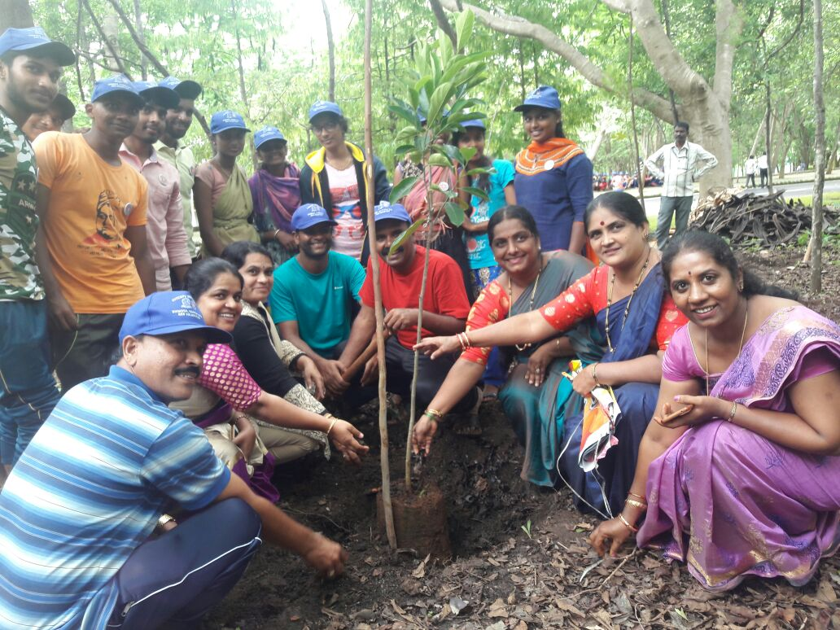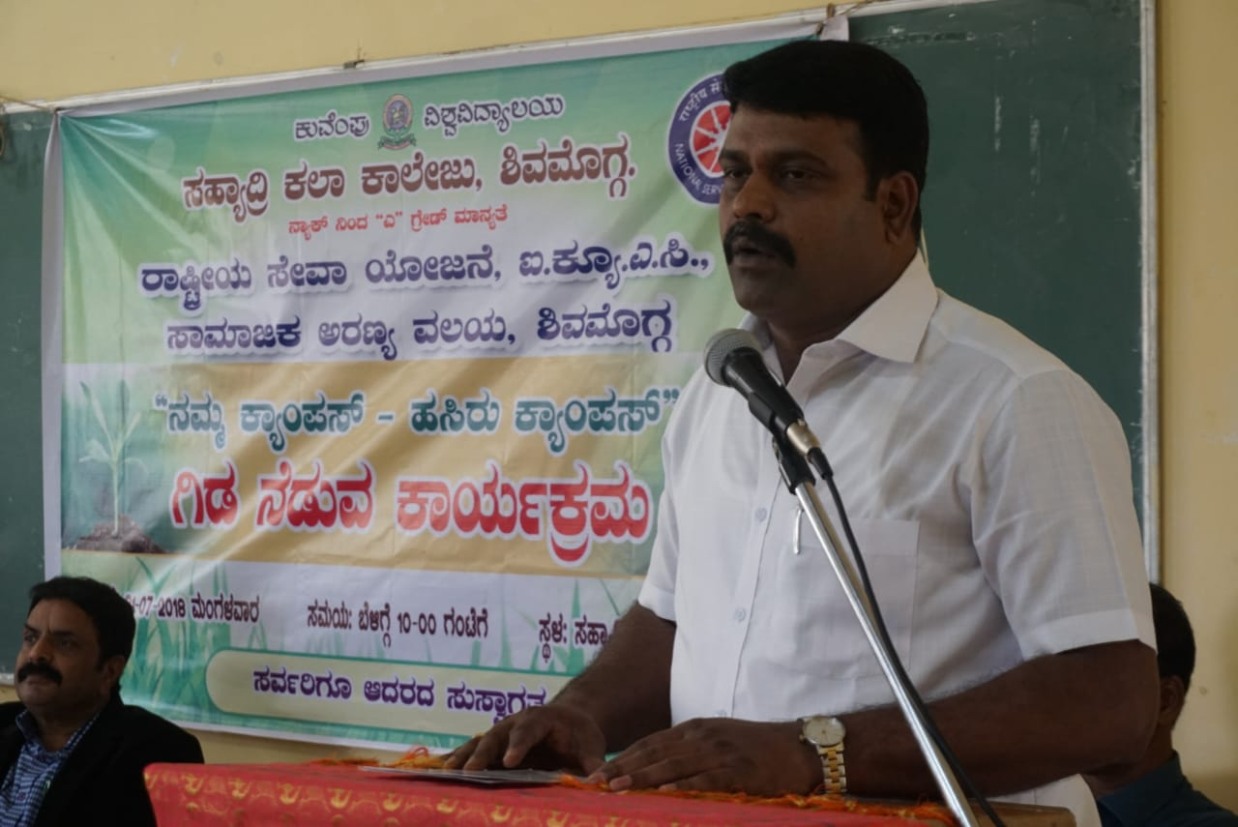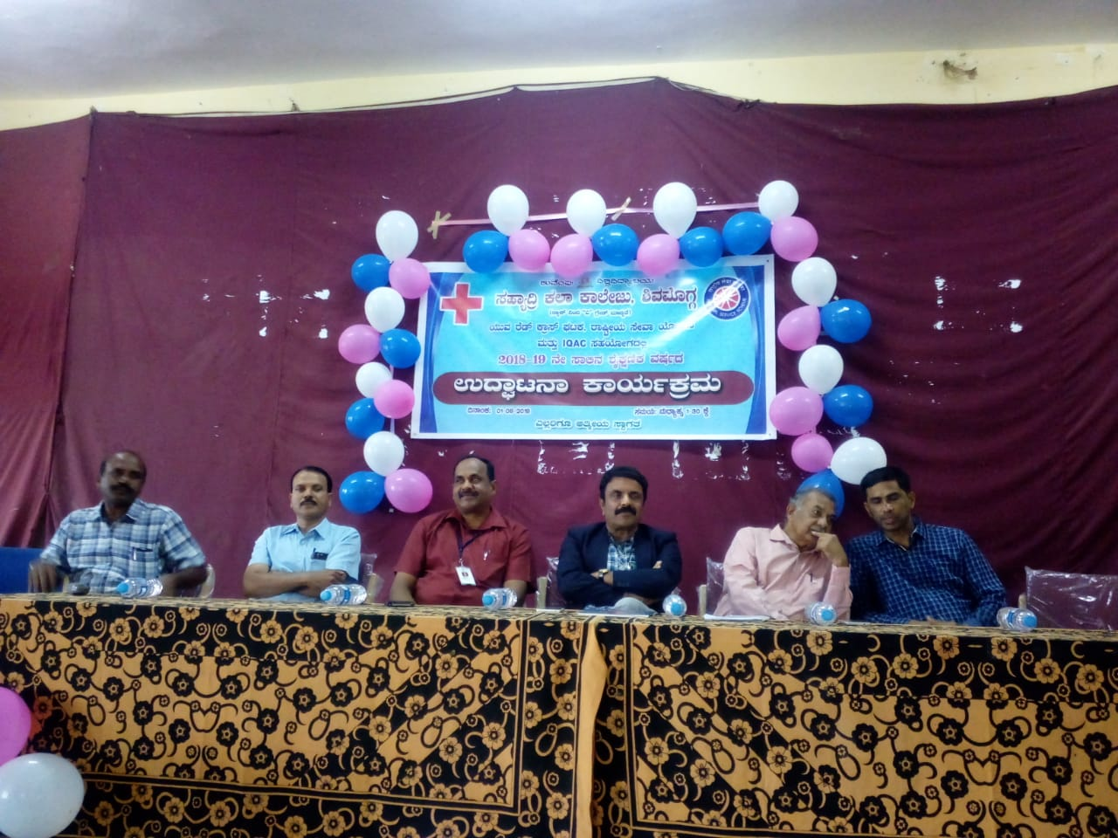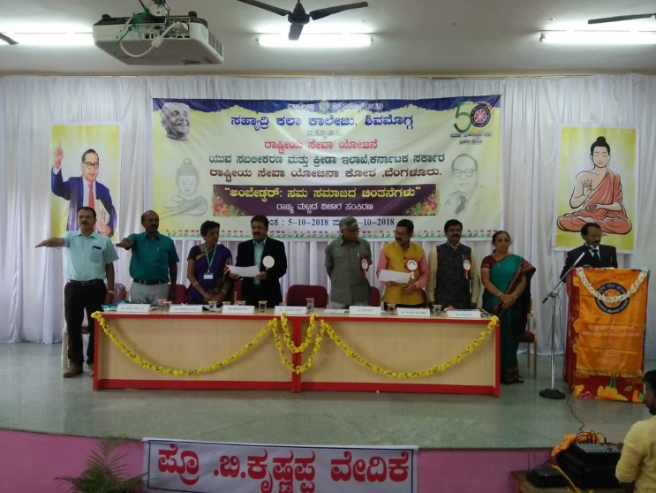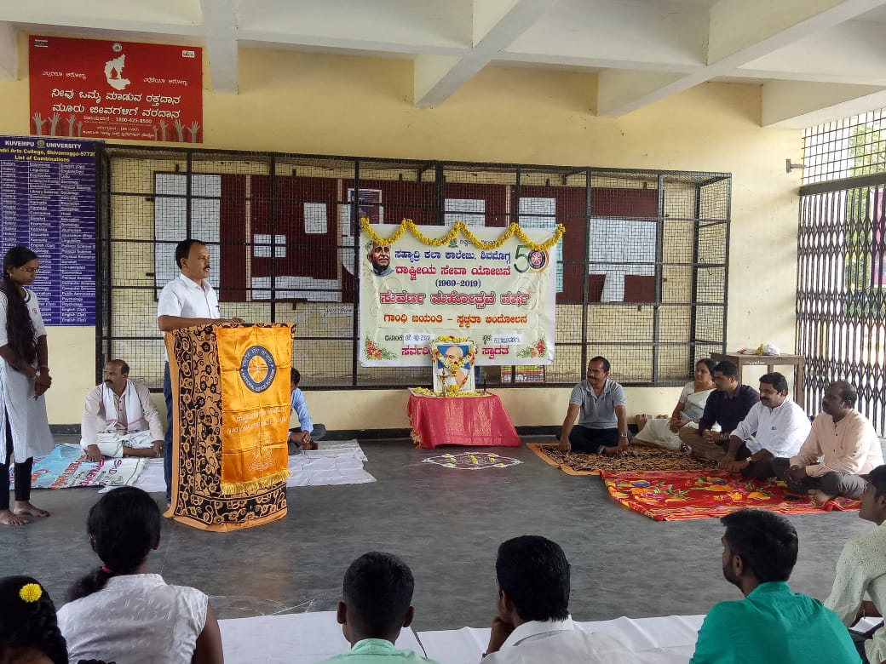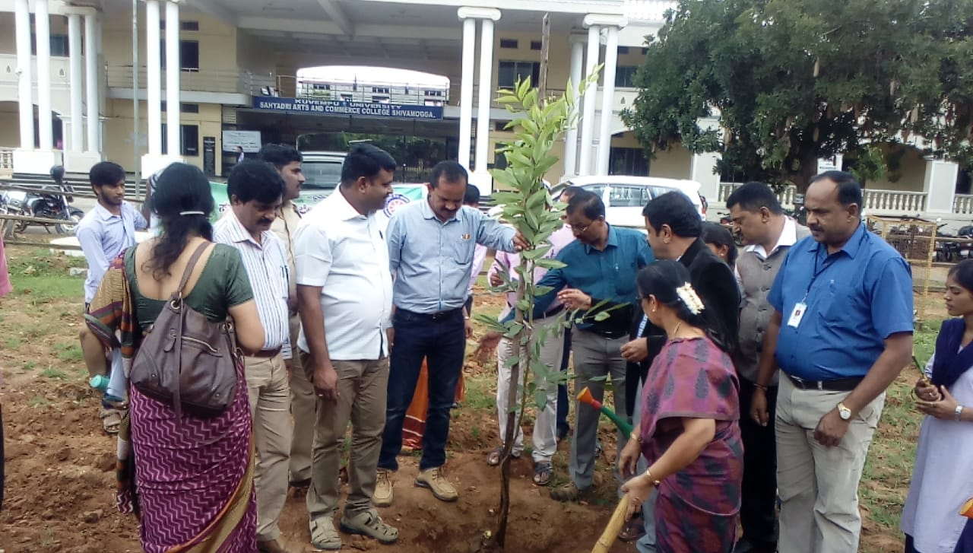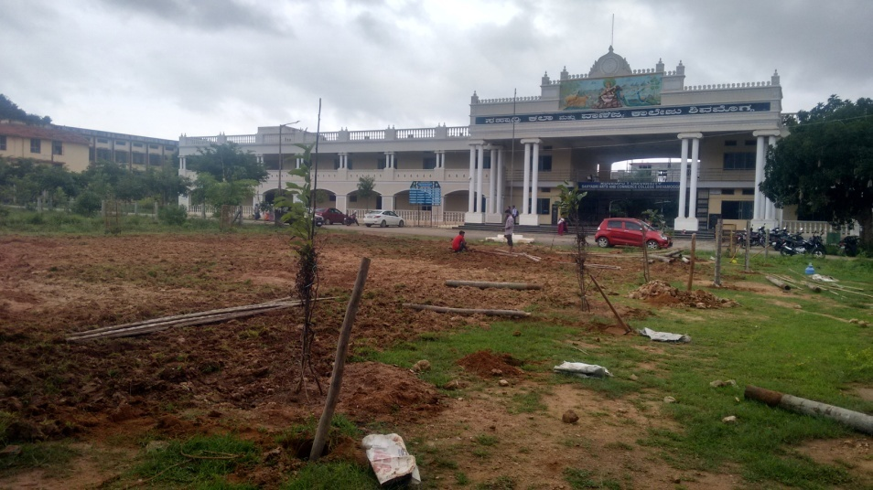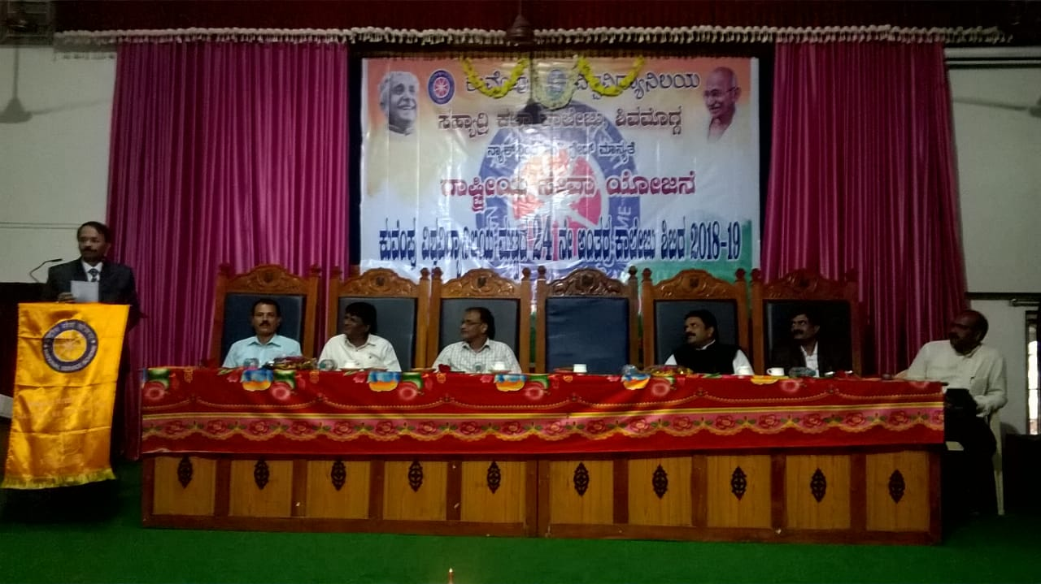s